
Pilgrim Lutheran Church building 1942-1958





2026

Pilgrim Lutheran Church - 1705 Nebobish Avenue, Essexville, Michigan
(989)893-7224 ♦ pilgrimessexville@gmail.com

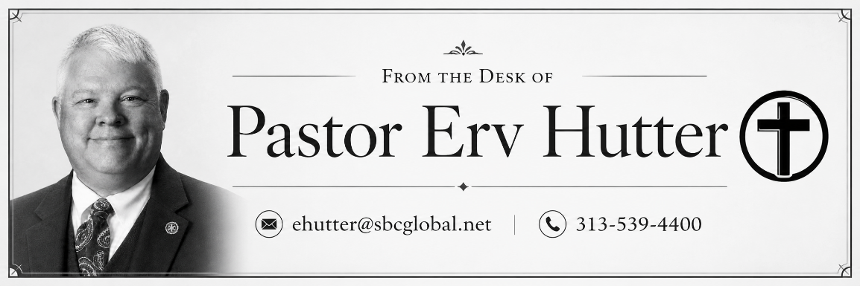
The Bible is filled with angels. They stand at the gates of Eden, appear to Abraham, ascend and descend the ladder in Jacob’s vision, announce the birth of Christ, rejoice over sinners who repent, minister to Jesus, proclaim His resurrection, and appear throughout the Revelation to St. John. Yet angels are also among the most misunderstood figures in Christianity. Popular culture often portrays them as sentimental figures with wings and halos, departed loved ones who have “become angels,” or mysterious spiritual beings who exist primarily to guide us through life. The Lutheran understanding of angels begins somewhere much more reliable: with the Word of God.

Lutherans confess that angels are real, created spiritual beings who serve God and carry out His will. The word angel comes from a word meaning “messenger.” Angels are not gods, nor are they human beings who have died and gone to heaven. They belong to God’s creation and live under His authority. As Psalm 103 declares, “Bless the LORD, O you His angels, you mighty ones who do His Word, obeying the voice of His Word!”

Holy Scripture speaks of both holy angels and fallen angels. The holy angels remain faithful to God and serve Him continually. The fallen angels rebelled against God under Satan and now oppose God’s purposes. This spiritual conflict is real, but it is not a struggle between equal powers. Satan is not God’s equal. He is a defeated angel. Through His death and resurrection, Jesus Christ has conquered sin, death, and the devil.

The Lutheran understanding of angels is therefore thoroughly Christ-centered. Angels may be glorious creatures, but they are never the center of the Christian faith. Jesus is. Angels themselves direct attention away from themselves and toward God’s saving work.

At Bethlehem, they proclaim the birth of the Savior. At the empty tomb, they announce, “He is not here, for He has risen.” At Christ’s ascension, they point His disciples toward His promised return.

Scripture also teaches that God sends His angels to serve and protect His people. Hebrews calls them “ministering spirits sent out to serve for the sake of those who are to inherit salvation.”

Luther beautifully reflected this biblical confidence in his Morning and Evening Prayers when he taught Christians to pray: “Let Your holy angel be with me, that the evil foe may have no power over me.”

Yet Christians do not worship angels, pray to them, or seek secret messages from them. We pray to God through Jesus Christ and trust the promises He has given us in His Word, Baptism, and the Lord’s Supper.

In a new Sunday morning Bible class, we will explore what Scripture actually teaches about angels: What are angels? Do we have guardian angels? What are cherubim and seraphim? Who are Michael and Gabriel? What happened to the fallen angels? How do angels serve Christians? What role will they have at Christ’s return?

Beginning on September 20, join us Sunday mornings from 9:00–10:00 a.m. as we move beyond legends and popular images to discover the fascinating, comforting, and Christ-centered biblical teaching concerning God’s holy angels.

In HIS Service

Rev. Erv Hutter


ATTENDANCE & CONTRIBUTIONS (Needed Weekly 2026: $2,939.60)
07/25 On-line: N/A In-Person Worship: 18 $ 715.00
07/26 On-line:130 In-Person Worship: 32 $1,793.00
08/02 On-line: 89 In-Person Worship: 42 $2,377.00
08/09 On-line: 96 In-Person Worship: 38 $1,911.00
08/16 On-line: 180 In-Person Worship: 55 $2,715.60
08/23 On-line: 65 In-Person Worship: 40 $2,736.31
September 15

General Fund Year-To-Date Actual vs. Budget $553.14

SPECIAL GIFTS: $50 Memorials (Gary Sloan), $15 Organ, $85 Rainy Day, and $2,810 Roof Replacement

PASTORAL ACTS – Baptisms of Carter Ferrer and Hannah Thume 8/15/26

SPECIAL ENVELOPES:
In addition to being able to sponsor Altar Flowers and our Order of Worship each week (sign-up sheets for 2026 and envelopes are in the hallway), we also have a variety of special envelopes available in the Narthex for these extra giving opportunities:

Community Care Fund – Gifts donated to this fund are sent to one of our many community organizations.

Love Offering Envelopes – For when you’d like to make an extra donation in order to honor or celebrate a special occasion or someone special.

Memorials – Donations may be made in memory of friends and family.

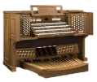
Organ Fund – We use the money in this fund to help regularly maintain and tune our pipe organ which is a major asset to our worship experience.


Orphan Grain Train – These gifts are sent to assist with helping those in need both here in the U.S. and abroad.


Rainy Day – Gifts given to this fund are of vital importance as we need to use it when our expenses of running the church don’t keep up our weekly tithes and offerings.

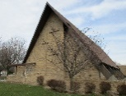
Roof Replacement Fund – In order to keep a roof over our heads, we established a fund last August to cover the cost of replacing the roof. We have contracted with Brown Roofing, a local company, to replace the roof. Work began on Thursday, August 20 and the first phase (the asphalt shingles over the worship center) was completed on Friday, August 21. The second phase (the flat roof over the rest of the building will likely be done in late September or early October. On August 20, we also received a generous donation from the trust fund of a deceased member that completely covers the cost of the entire project. We will say more about this donation at a later date, but God be praised!

BIBLE STUDY OPPORTUNITIES:

Pastor Erv is busy preparing for our weekly Bible Studies that are set to begin in September:
- Tuesday Evening Sessions will begin at 7:00pm on Tuesday, September 8 and will be based upon the book of Psalms.
- Sunday Morning Sessions will be from 9:00am – 10:00am beginning September 20 with a look at what Scripture says about angels!
Email Ministry:
Did you know we can send you the latest info from the church office? If you can’t make it to church on Sunday, you can still read/sing along with the service online! If you’re not receiving our weekly email, Please, email pilgrimessexville@gmail.com with your name, current email address, and cell phone number so we can continue to build this data base and verify the information with our Shepherd’s Staff program.


TRUNK OR TREAT:
Our Cub Scout Pack 3113 will once again be sponsoring a Trunk or Treat for the community on Saturday, October 31. Keep watching for more details as well as a box in the hallway for your candy donations. If you’d like to open your trunk in the parking lot, setup will begin at 3:00pm with the actual trick-r-treating to begin at 4:00pm.
SIGN UP POSTERS:

Check out the hallway bulletin board – you may reserve YOUR special date for the rest of 2026! Please use the appropriate envelopes located next to the signup posters and return them to the church office at least two weeks before your special date.
- Altar Flowers $25 cash so the Altar Guild can purchase the flowers for you.
- Sponsorship of Worship Folders $25 cash or check – this will help offset printing costs for the Sunday bulletin and News & Notes.
- Signups are also available for our weekly Sunday Fellowship Refreshments and our monthly Fellowship Events
KEENAGER MONTHLY GATHERINGS:

Our “Keenagers” are those members of our congregation who are just past middle age and like to gather for fellowship and a meal. All members (and friends of the congregation) are invited to meet in the Education Room on the 2nd Tuesday of every month at 11:00 am, for a potluck meal, usually a short devotion by Pastor, and then spend as much time in the afternoon as you’d like playing cards or other fellowship activities. Our next gathering is set for Tuesday, September 8. See you there!
CHRISTIAN BROADCASTING:
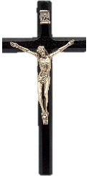

Many people are watching or listening to broadcasts of religious services on the television or radio. Perhaps you have listened to the Lutheran Hour radio broadcast on WSAM (AM 1400) Sunday mornings at 8:30 am or Immanuel Lutheran Radio Broadcast on Sunday morning at 9:00 am on WSAM (AM 1400) or watched the Worship Anew television program broadcast from Fort Wayne, Indiana, on WAQP 49 (Spectrum Channel 2) Sunday mornings at 11:30 am. All three of these ministries are seeking financial support. If interested, donations may be sent to:
Saginaw Valley Lutheran Hour, PO Box 133, Frankenmuth MI 48734
Immanuel Lutheran Radio Ministry, 300 N Sheridan St, Bay City, MI 48708
Worship Anew, Lutheran Ministries Media, 5 Martin Luther Dr, Ft Wayne IN 46825

FALL CRAFT SHOW:
This event is hosted by our own Cub Scout Pack 3113 and is being planned for Saturday, November 21st, from 10:00 am - 3:00 pm. Mark your calendar so you don’t miss out!
BOARD OF CHRISTIAN EDUCATION:
Board of Christian Education Members will meet on Sunday, October 11 at 11:30am after the worship service in the Education Center.

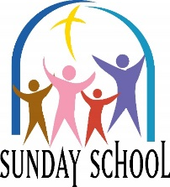
*** Sunday School resumes in September on Sunday mornings from 9:00-10:00am with sessions on September 13 and 27. Be sure to mark your calendar and join us!

*** Sunday School children will continue learning through the Enduring Faith Bible Curriculum (Concordia Publishing) Unit 8 – Jesus Saves the World:
- Mary and Martha – Luke 10:38-42
- Jesus Seeks the Lost – Luke 15
- Jesus Heals a Man Born Blind – John 9
- Jesus Raises Lazarus – John 11:1-44

*** Library News – Please do feel free to go into our library after church on Sunday to browse and take a book home to enjoy. When returning it, please place it within the same category from which it had been taken.
All newly donated items are to be placed in the plastic container in the corner of the library room.
We hope you enjoy spending some time in our library!

*** Thrivent Generosity in-person information/update session: Join us on Sunday, September 20 at 11:30am after the worship service in our Education Center. Dave Friebe will be here from Thrivent to explain and answer questions on these generosity options:

- Thrivent Action Teams
- Thrivent Choice Dollars
- Cause Kits
God’s Word for Everyone vs 3
The Bible tells how Jesus rose again;
He rose in victory,
His death rescued you and me.
Alleluia!




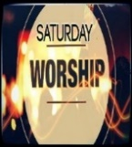

SATURDAY WORSHIP:
Join us on these Saturdays at 5:00pm for Holy Communion in the Blue Room Chapel:
September 26, October 24, and November 28. Be sure to mark your calendar for these extra worship opportunities as they usually are a totally different service than Sunday’s.
CHURCH EXTENSION FUND:
In celebration of its 125th Anniversary, Church Extension Fund is launching the Ministry Partner Bonus Grant! How to participate:
- Open a new CEF note of $1,000 or more with a term of at least 24 months
- Pilgrim will automatically receive $125 Bonus Grant
- Limit one grant per household
- Visit churchextensionfund.com to get started
PILGRIMS SERVING IN SEPTEMBER
Sunday Elder – Mark Anthony

September 6 Count Team 4
September 13 Count Team 1
September 20 Count Team 3
September 27 Count Team 2
October 4 Count Team 4

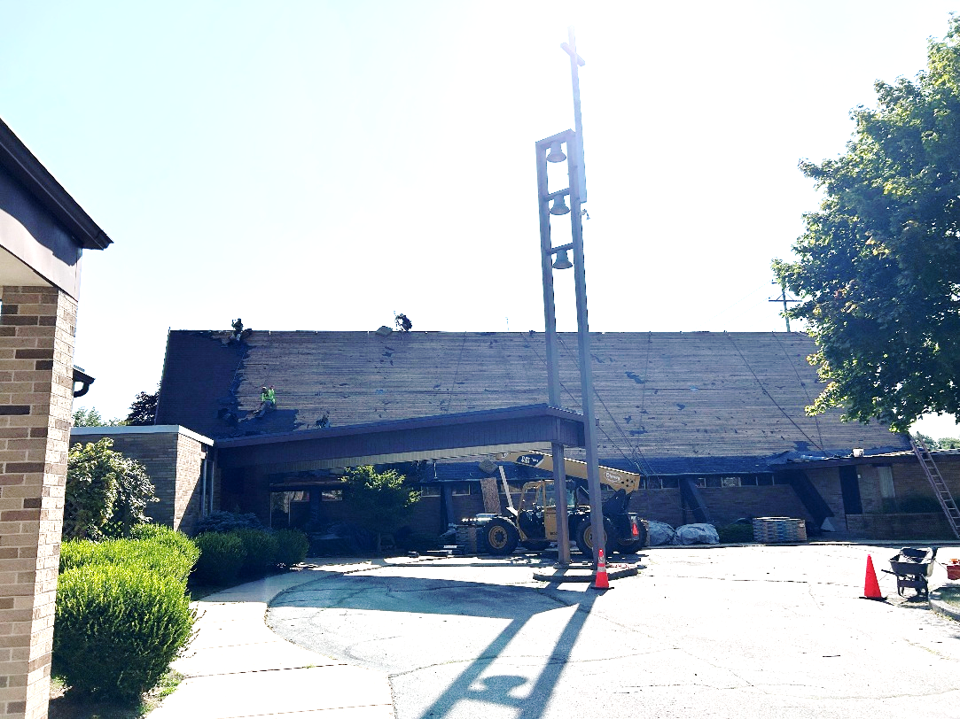

PILGRIM FELLOWSHIP EVENTS:
The Fellowship Team (and others) are making preparations for these fun events and activities so be sure to mark your calendar and join us:
- September 26 – Campfire Picnic after the Saturday night worship service – a signup sheet is now on the hallway bulletin board!
- October 25 – Harvest Dinner and Bingo
- October 31 – Cub Scout Trunk or Treat
- November 21 – Cub Scout Fall Craft Show
- November 28 – Decorate the Church
- December 6 – Soups On and Christmas Mystery Bingo
- December 12 – Women’s Guild Holiday Bake Sale
- February 7 – Pizza and Bingo
- February/March – Lenten Dessert Fellowship
- April 11 – New Member Potluck
Keep watching for more details
as the events get closer!



Roofers tearing off the old shingles and preparing for the new.

2026

Sun | Mon | Tue | Wed | Thu | Fri | Sat
 |  | 1  Wendy VanOoteghem | 2  Jerry Brigham | 3  Vicki Schnettler | 4 | 5
6 | 7 | 8 | 9 | 10  Melissa Corrion | 11 | 12  Dave Borchardt  Suzanne Gibbs
13 | 14 | 15  Carol Smith | 16  Reese Miller | 17 | 18 | 19  Mike Massey
20 | 21 | 22  Claire Schulz  Chris Wagner | 23  Sharon Grigg | 24 | 25 | 26
27 | 28 | 29 | 30


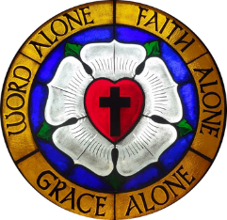



20266

Sun | Mon | Tue | Wed | Thu | Fri | Sat
 |  | 1 | 2 | 3  9³⁰ Chair Exercise | 4 | 5
6 Trinity 14  10³⁰ Holy Communion  11³⁰ Fellowship | 7 Labor Day | 8  11⁰⁰ Keenagers  6³⁰ Cub Scouts  7⁰⁰ Bible Class | 9  3³⁰ Confirmation | 10  9³⁰ Chair Exercise | 11 | 12
13 Trinity 15  9⁰⁰ Sunday School  10³⁰ Holy Communion  11³⁰ Fellowship | 14 | 15  Newsletter  Deadline  6³⁰ Cub Scouts  7⁰⁰ Bible Class | 16  3³⁰ Confirmation | 17  9³⁰ Chair Exercise  10⁰⁰-12⁰⁰ Home Visitation | 18 | 19
20 Trinity 16  9⁰⁰ Bible Class  10³⁰ Holy Communion  11³⁰ Fellowship and Thrivent Presentation | 21 | 22  11⁰⁰ Women’s Guild  6³⁰ Cub Scouts  7⁰⁰ Bible Class | 23  3³⁰ Confirmation | 24  9³⁰ Chair Exercise | 25 | 26  5⁰⁰ Holy Communion  Fellowship Campfire Picnic following the service
27 Trinity 17  9⁰⁰ Bible Class  9⁰⁰ Sunday School  10³⁰ Holy Communion  11³⁰ Fellowship | 28 | 29  6³⁰ Cub Scouts  7⁰⁰ Bible Class | 30  3³⁰ Confirmation | 31  9³⁰ Chair Exercise



1705 Nebobish Avenue
Essexville, Michigan 48732

Penzien-Steele Funeral Home has underwritten the cost of production and mailing this month’s Pilgrim’s Progress

