


Pilgrim Lutheran Church building 1942-1958





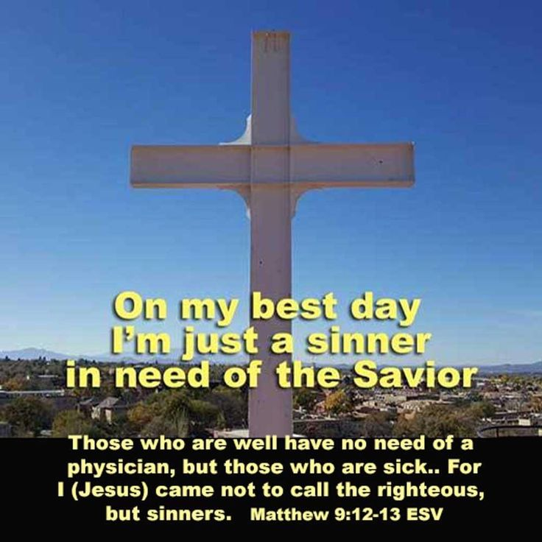
Pilgrim Lutheran Church • 1705 Nebobish Avenue • Essexville, Michigan 48732

pilgrimessexville@gmail.com 989.893.7224


I used to be a “news junkie”; I’d have Headline News® playing in the background of my office 24/7. That was then, this is now. Today, I can’t bring myself to listen to broadcast news, at all. There is very little “good news”; it’s all telling us how bad things are. For me, I already know this. I don’t need constant reminders about how bad the world is, or daily examples that the world is a broken place.
I do read headlines on the internet, and if I want to know more, I will sometimes click on the news account.
Recently, I read the account of how 33 years after his death, people are now accusing National Farm Workers Association co-founder, Cesar Chavez, of sexual improprieties.
It is certainly difficult to know the truth of events that happened between individuals 30, 40, or 50 years after they occurred, especially if one of the parties to the events is no longer able to give their side of what may or may not have occurred. The accusations are serious and ugly and troubling.
Some states and municipalities have for more than 30 years honored the memory of Chavez as someone who was worthy of remembrance due to the activities of his life and service.
Now some of those same people and organizations and governments are saying that if the accusations of his private conduct are true, then his memory should not be honored.
There is a catch phrase for this phenomenon, called “cancel culture”. It happens on the left and right sides of our political spectrum and is becoming more and more of a way for people to express themselves.
Martin Luther had a different way of dealing with this. Simul justus et peccator is a Latin phrase meaning "simultaneously justified and a sinner."
This is a foundational doctrine describing the Christian life as being fully righteous in God's sight through Christ's imputed righteousness, while still remaining intrinsically sinful. Every person may be a saint and a sinner at the same time.
George Washington, Thomas Jefferson and Andrew Jackson were viewed in the past as founding fathers of our country and heroes to be remembered and honored. They were also slave owners and treated Native Americans horribly. They were saints and sinners, in need of a Savior. And Jesus Christ is that one and only Savior.
Each of us are saints and sinners. We try to show ourselves to others to be “good people”. But if others could see our hearts, know our private sins, they would be appalled.
I don’t know the best way to go forward as Americans. There are no perfect people to remember and honor if our threshold of honor is perfection.
All sin and fall short from the glory of God.
If Chavez’ sexual sin is true, then his personal remembrance is difficult to honor, but does that change the public work that he did? Is that still worth honoring?
Other current and historical “heroes” to some have been accused of private deeds that are not honorable. These include many of our past political and social leaders, and even our current president. But does this private activity negate the public good that some have done? Our society will continue to struggle with this question.
But for each of us individually, we need to recognize our own shortcomings. We need to confess our sinfulness, knowing that when we do, our merciful God forgives completely.
We are all saints and sinners at the same time, and we are all in constant need of a Savior.
To expect that there is anyone who doesn’t have things in their life that is embarrassing or unexplainable is shear folly. Perhaps this is one of the greatest reasons that we can’t get otherwise quality people to run for political office in our communities, state, and nation.
For our part, we need to recognize that just like you and me, no one is without some level of guilt.
There is no one that is sinless. Not political leaders, not societal leaders, not even pastors. There was a time when I think our society understood this better. I’m not saying that we should condone sin, no, not ever. Sin must be dealt with.
A huge part of “dealing with” any sin is confessing it, whether publicly or privately. Private sin should be confessed privately, and public sin should be confessed publicly. And all confessed sin should be absolved, not forgotten, not normalized, not turned into “non-sin”, but absolved in the sight of God, and reckoned with in the sight of community.
Just maybe, in Cesar Chavez’ case, we should recognize his accomplishments and remember that his private conduct was not as enviable as his public service. History will decide.
For you and me, we need to be able to forgive the sinfulness of those who are repentant, in the same manner that we seek forgiveness for our own transgressions.
O, how we truly need a Savior! Thank the Lord that He sent Jesus Christ to be that Savior!


In HIS Service

Rev. Erv Hutter


PILGRIMS SERVING IN APRIL
Elders: Gary Leinberger (893-5433)
Glenn Grage (906-0012)
April 16
Altar Guild: Alice Kryszak (893-3664)
Trustee: Kevin Kot (225-2913)


Count Teams:
April 5 Team 2
April 12 Team 3
April 19 Team 4
April 26 Team 1
May 3 Team 2

Pastoral Acts: New Members – Charles and Kathleen Ward

ATTENDANCE & CONTRIBUTIONS (Needed Weekly in 2026: $2,939.60)
02/25 Lent On-line: 76 In-Person Worship: 22 $ 95.00

02/28 Saturday On-line: 97 In-Person Worship: 15 $ 1,410.00
03/01 Sunday On-line: 58 In-Person Worship: 40 $ 5,479.00
03/04 Lent On-line: 124 In-Person Worship: 19 $ 190.00
03/08 Sunday On-line: 100 In-Person Worship: 44 $ 1,505.20
03/11 Lent On-line: 90 In-Person Worship: 21 $ 396.00
03/15 Sunday On-line: 87 In-Person Worship: 29 $ 1,504.00
03/18 Lent On-line: 73 In-Person Worship: 22 $ 345.00
03/22 Sunday On-line: 79 In-Person Worship: 62 $ 4,788.00

General Fund vs. Budget Year-To-Date $2,723.59

SPECIAL FUNDS: Rainy Day Fund $70, Roof Replacement $450, and Waterline Repair $3,105

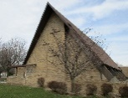
Donation Totals to Date for our repair projects:
Roof Replacement $21,915.81 and Waterline Repair $3,105 (The latest issue has been resolved and the repair bill is $3,592.48 so we almost have it paid off! Thank you!)

Join us and invite a friend for our Holy Week services:
Maundy Thursday, April 2 @ 5:00pm (in the Blue Room Chapel)
Good Friday, April 3 @ 5:00pm (in the Blue Room Chapel)
Easter Sunday Celebration, April 5 @ 10:30am (in the Sanctuary)

KEENAGER MONTHLY GATHERINGS

Our “Keenagers” are those members of our congregation who are just past middle age and like to gather for fellowship and a meal. All members (and friends of the congregation) are invited to meet in the Education Room on the 2nd Tuesday of every month at 11:00 am, for a potluck meal, usually a short devotion by Pastor, and then spend as much time in the afternoon as you’d like playing cards or other fellowship activities. Our next gathering is set for Tuesday, April 14. See you there!

BIBLE STUDIES
Tuesday Evening Adults:
We continue our study of the books of the Bible with the Old Testament on Tuesday evenings at 7:00pm. You are welcome to join us in the Education Room any Tuesday you are available.
Sunday Morning Adults:
Each Sunday from 9:00-10:00am, we meet in the Education Room for Bible study. We are going through the hymns of the week. Join us any Sunday that you’d like.

EMAIL MINISTRY
Did you know we can send you the latest info from the church office? If you can’t make it to church on Sunday, you can still read/sing along with the service online! Please, email pilgrimessexville@gmail.com with your name, current email address, and cell phone number so we can build this data base. If you’re not receiving our weekly email, please send us your current information and Deadra will cross-reference this new info with our Shepherd’s Staff program.
SIGN-UP POSTERS
See the hallway bulletin board – you may reserve YOUR special date for the rest of 2026! Please use the appropriate envelopes located next to the signup posters and return them to the church office at least two weeks before your special date.

- Altar Flowers $25 cash so the Altar Guild can purchase the flowers for you.
- Sponsorship of Worship Folders $25 cash or check (made payable to Pilgrim) – this will help offset printing costs for the Sunday bulletin and News & Notes.

- Refreshments for Sunday Fellowship

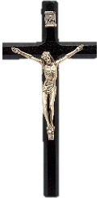

WORSHIP BROADCASTS
Many people are watching or listening to broadcasts of religious services on the television or radio. Perhaps you have listened to the Lutheran Hour radio broadcast on WSAM (AM 1400) Sunday mornings at 8:30 am or Immanuel Lutheran Radio Broadcast on Sunday morning at 9:00 am on WSAM (AM 1400) or watched the Worship Anew television program broadcast from Fort Wayne, Indiana, on WAQP 49 (Spectrum Channel 2) Sunday mornings at 11:30 am. All three of these ministries are seeking financial support. If interested, donations may be sent to:
Saginaw Valley Lutheran Hour, PO Box 133, Frankenmuth MI 48734
Immanuel Lutheran Radio Ministry, 300 N Sheridan St, Bay City, MI 48708

Worship Anew, Lutheran Ministries Media, 5 Martin Luther Dr, Ft Wayne IN 46825
CHAIR EXERCISE

Our low impact Chair Exercise group continues to meet in the Blue Room every Thursday morning from 9³⁰-10³⁰am. You don’t need any special equipment, just show up any Thursday that you can.
MONTHLY PASTORAL VISITS
Each month on the 3rd Thursday of the month, Pastor Hutter visits our homebound and shut-in members of the congregation, bringing communion. If you would like a home visit, please call the church office, at 989-893-7224. Generally, all visits are made in the morning, but other times can be arranged.

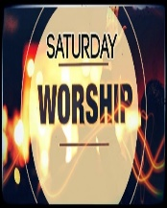
SATURDAY WORSHIP
Our Saturday worship will resume in April. This service, which usually utilizes totally different scripture readings and sermon, will be celebrated with Holy Communion and held in the Blue Room Chapel. Plan on attending April 25 and then May 30 at 5:00pm.
CHURCH LIBRARY
Over the past few months, we have been converting one of the old Sunday School rooms into a new church library. We have had some Thrivent Action Grants applied toward this effort. Gary Leinberger has built two of the eventual seven wooden bookshelves. The area has been repainted by Kevin Kot. This will be different from our current library in that the books will be those that you donate: novels, mysteries, biographies, or whatever other appropriate books that you have read and would allow others to borrow and read for themselves. While there certainly will be books of a religious nature, we are not restricting our options to only religious books. The area is adjacent to our relatively new gathering area near the Sunday School that has couches, an electric fireplace, comfortable chairs, a Keurig Coffee maker and even a dining room table. When we fully roll out this concept, this area will be accessible during our regular business hours, and upon request at other times for individual or small group gatherings, to read a book, do a puzzle, play a game, or other such activities. Lynda Allen is organizing the books for use by genre. We still need to raise the funds for the other five bookshelves, which are around $250 each. We’ll keep you posted as this project progresses.
In the meantime, our current church religious library is open for your use by the north entrance near the kitchen.




This Little Light of Mine
Jesus gave it to me, I’m gonna let it shine;
Jesus gave it to me, I’m gonna let it shine;
Jesus gave it to me, I’m gonna let it shine,
Let it shine, let it shine, let it shine.

BOARD OF CHRISTIAN EDUCATION
Our members include: Lynda Allen, Kathy Kemp, Barbara Massey, Bonnie McIntosh, Melissa Sofian, Donna Stagray, Sharon Weiler, and Adeline Wicker.

CARD MINISTRY
Bonnie McIntosh continues her card ministry to remember our shut-ins with mailings about every six weeks. She also provides for the purchase and mailing of Easter cards.


SAVE THE DATES
Be sure to mark your calendar as our Sunday School Sessions will be held on Sunday mornings from 9:00 – 10:00am on:
April 19
May 3
May 17

APRIL SUNDAY SCHOOL SERVICE PROJECT
Our Thrivent Action Team Service Project will run April 6 through April 26. It is a Shoe Drive with Foster Families Navigation & Resource Center – Bay City.
Donations of new or gently used shoes that still have life will help stock the local Foster Families Center and go to poverty-stricken countries.

Totes will be provided by the Center for the shoe collection and will be located in the hallway area.


Seed money has been used for education materials for the Sunday School children of Pilgrim to learn about Jesus and participate with their families, friends, and church members in loving their community neighbors through this local shoe drive. Also, further seed money was used to purchase several pairs of new shoes for the Sunday School children to place in the totes to begin the service project.

UNIT 8 – Jesus’ Ministry, Death, and Resurrection
- Jesus Appears to Thomas
  - John 20:19-31
- Jesus Teaches about Offerings
  - Mark 12:41-44

CHURCH LIBRARY
The Board of Christian Education is proud to work hand-in-hand with Thrivent Action Team Grants (2 were approved) and all the volunteers from Pilgrim to make this project happen so quickly!
Lynda Allen continues to work with her team over the next several weeks to unbox and shelve the totes of donated books.
See the above article for more library details!
CUB SCOUT CRAFT SHOW
Our Cub Scout Pack 3113 will be hosting a Spring Craft Show on Saturday, April 18. Keep watching the News & Notes for further details!

VOLUNTEERS NEEDED
We are looking for a few volunteers to take turns cutting the grass this summer on the church grounds. If you’re able to lend a hand, please sign up on the bulletin board and Kevin will be in touch with you for a schedule. Thanks!
News from our Women’s Guild!
** Pilgrim will be hosting the Bay City area
LWML Spring Rally on Saturday, April 25
Keep watching for registration details!
** Plans are also underway for the 2026 Essexville Rummage Sale Weekend
May 15 and 16
Keep watching for details on how you can be a part of this fundraising opportunity!







Sun | Mon | Tue | Wed | Thu | Fri | Sat
 |  |  | 1 | 2 | 3  Lorraine Straub | 4
5 | 6  Sharon Carlin | 7 | 8 | 9 | 10 | 11  Billie Kussro  Donna Roller
12 | 13  Sue Hutter | 14 | 15 | 16 | 17  Neal Grigg | 18
19 | 20  Jeff D’Archangel  Colleen Evans  Melissa Sofian | 21 | 22 | 23  Kenzie Sofian | 24 | 25
26  Ron Jankens | 27 | 28  Verlene Stiefel | 29  Tina Coones | 30
A Blessed and Happy Birthday







Sun | Mon | Tue | Wed | Thu | Fri | Sat
 |  |  | 1 | 2 Maundy Thursday  9³⁰ Chair Exercise  5⁰⁰ Maundy Thursday Worship  (in the Blue Room Chapel) | 3 Good Friday  5⁰⁰ Good Friday Worship  (in the Blue Room Chapel) | 4
5 Easter  10³⁰ Easter Celebration with Holy Communion | 6 | 7  6³⁰ Cub Scouts  7⁰⁰ Bible Study | 8 | 9  9³⁰ Chair Exercise | 10 | 11  Fellowship Hall Rental
12 Easter 2  9⁰⁰ Bible Class  10³⁰ Holy Communion  11³⁰ Fellowship | 13 | 14  11⁰⁰ Keenagers  6³⁰ Cub Scouts  7⁰⁰ Bible Study | 15 | 16 Newsletter Deadline  9³⁰ Chair Exercise  Home Visits 10⁰⁰-12noon | 17  Cub Scouts set up Craft Show | 18  Cub Scout Craft Show
19 Easter 3  9⁰⁰ Bible Class  9⁰⁰ Sunday School  10³⁰ Holy Communion  11³⁰ Fellowship | 20 | 21  11⁰⁰ Women’s Guild  6³⁰ Cub Scouts  7⁰⁰ Bible Study | 22 | 23  9³⁰ Chair Exercise | 24 | 25  LWML Spring Rally  5⁰⁰ Holy Communion
26 Easter 4  9⁰⁰ Bible Class  10³⁰ Holy Communion  11³⁰ Fellowship | 27 | 28  6³⁰ Cub Scouts  7⁰⁰ Bible Study | 29 | 30  9³⁰ Chair Exercise




1705 Nebobish Avenue
Essexville, Michigan 48732

1705 Nebobish Avenue
Essexville, Michigan 48732

