
Pilgrim Lutheran Church building 1942-1958




2026
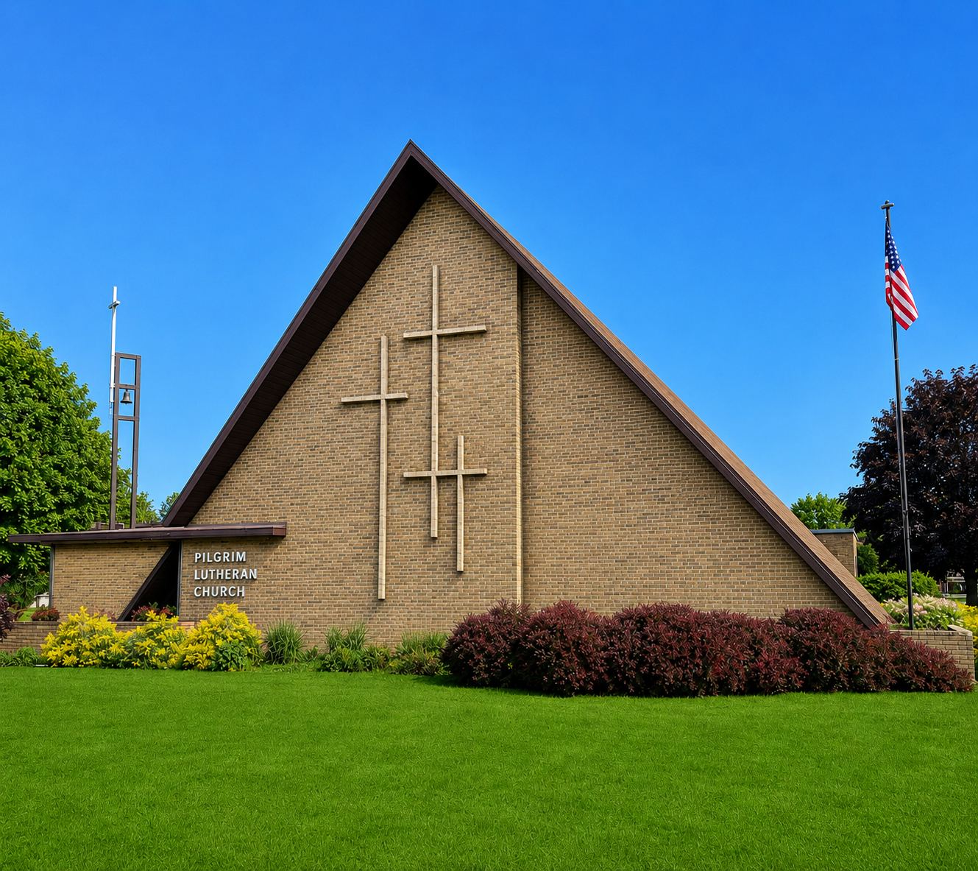
Pilgrim Lutheran Church - 1705 Nebobish Avenue, Essexville, Michigan
(989)893-7224 ♦ pilgrimessexville@gmail.com


20 Ways to Reach the Lost
How can you demonstrate God’s love in your community? Here are just a few things you might do:
- Pray fervently. Pray for not only your family and friends, but also for your pastor, your church leadership, fellow church members, your neighbors, people you know who aren’t practicing Christians, for our local state and national leaders, etc.
- Be an active school parent or grandparent. Prayer may not be allowed in the classroom, but the government can’t stop your light from shining in a school environment. Become friends with the principal, teachers, and other parents.
- Celebrate holidays in style. Gather neighbors, co-workers or relatives for Christmas or Easter. Then tell the old, old story of Jesus’ birth or resurrection in a brand-new way.
- Join a club. Writers’ groups, music clubs, and other common-interest organizations can open doors for you to share the gospel. Don’t avoid non-Christian gatherings.
- Coach a Little League team. Coaching or mentoring can initiate friendships and help you reach the younger generation.
- Build a cross-cultural bridge. Become friends with someone who looks different and has a different history.
- Adopt a child. We Christians admit that unwanted children need a home, but are we willing to play the role of parent to them? Or if you are not in a position to adopt, then support a pregnancy center or child welfare agency with your time and talents, and perhaps even your dollars.
- Become a pen pal. Prisoners have time to read mail. Who’s going to write them?
- Get a workout partner. Your lost neighbor needs exercise, too. Ask him or her to join you for regular visits to the fitness center.
- Go to places where people need not only your help, but your Christian advice. Who says you can’t visit a bar? Jesus didn’t let religious people dictate where He could or couldn’t go; neither should you.
- Bless your food server. Restaurant workers often complain that church people are more rude and tip less generously than others. Let’s change our image! Be friendly, listen, and don’t just leave a gospel tract; leave a big tip and when you give thanks, ask your server to join you, or if there is anything you can pray for them about.
- Feed the homeless. Local ministries in your area are touching these lonely people. Get involved, not only with dollars, but with your time and talent.
- Share a meal and a movie. Invite an adult neighbor over for a home-cooked dinner or a backyard barbecue, then watch a wholesome video.
- Send a card. Surprise unbelievers in your office with an expression of kindness on birthdays, holidays, or the anniversary of a painful memory.
- Help someone in crisis. Volunteer at a local hospital or with a meals-on-wheels program.
- Start an office Bible study. Get permission first, then have an informal time of sharing over a brown-bag lunch.
- Comfort someone dying of cancer or AIDS. Many cities need hospice volunteers to minister to the terminally ill.
- Become a Big Brother or Sister or a Scouting Volunteer. Scores of young children are raised in single-parent homes and need the influence of another adult to help them grow to maturity. Make one part of your life.
- Reach out to children in your neighborhood. Invite neighborhood children into your home (with their parents’ permission, of course) for cookies, a story, or a swim in your pool, and share the love of Jesus with them.
- Be a friend. Nowhere in the Bible are we told to shun contact with unbelievers. We are called to love and serve the people we meet in school, at work, and in our communities. Listen, offer encouragement, and wait for opportunities to share Christ.
These are just 20 ideas through which you can personally and individually reach out to those people who need your Christian love. I’m sure that you can come up with at least 20 more. But find your niche, your calling, and do it, do it now. Be the hands of Christ to the broken people in your world today…

In HIS Service

Rev. Erv Hutter


ATTENDANCE & CONTRIBUTIONS (Needed Weekly 2026: $2,939.60)
06/27 On-line: 97 In-Person Worship: 17 $ 890.00
06/28 On-line: 93 In-Person Worship: 40 $1,250.00
07/05 On-line: 81 In-Person Worship: 45 $2,808.00
07/12 On-line: 96 In-Person Worship: 44 $2,038.52
07/19 On-line: 60 In-Person Worship: 50 $2,884.07
August 13

General Fund Year-To-Date Actual vs. Budget $3,003.23

SPECIAL GIFTS: $50 Love Offerings, $50 Organ, $110 Rainy Day, and $765 Roof Replacement

PASTORAL ACTS – Funeral of Gary Sloan 7/29/26

KEENAGER MONTHLY GATHERINGS:

Our “Keenagers” are those members of our congregation who are just past middle age and like to gather for fellowship and a meal. All members (and friends of the congregation) are invited to meet in the Education Room on the 2nd Tuesday of every month at 11:00 am, for a potluck meal, usually a short devotion by Pastor, and then spend as much time in the afternoon as you’d like playing cards or other fellowship activities. We’re taking a break for August, but our next gathering is set for Tuesday, September 8. See you there!
SPECIAL ENVELOPES:
In addition to being able to sponsor Altar Flowers and our Order of Worship each week (sign-up sheets for 2026 and envelopes are in the hallway), we also have a variety of special envelopes available in the Narthex for these extra giving opportunities:

Community Care Fund – Gifts donated to this fund are sent to one of our many community organizations.

Love Offering Envelopes – For when you’d like to make an extra donation in order to honor or celebrate a special occasion or someone special.

Memorials – Donations may be made in memory of friends and family.
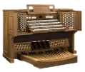
Organ Fund – We use the money in this fund to help regularly maintain and tune our pipe organ which is a major asset to our worship experience.

Orphan Grain Train – These gifts are sent to assist with helping those in need both here in the U.S. and abroad.

Rainy Day – Gifts given to this fund are of vital importance as we need to use it when our expenses of running the church don’t keep up our weekly tithes and offerings.
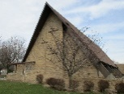
Roof Replacement Fund – In order to keep a roof over our heads, we established a fund last August to cover the cost of replacing the roof. We have contracted with Brown Roofing, a local company, to replace the roof this year. It will likely happen yet this summer and fall. Due to the war and economy, the price is now $130,000. We have applied, but will not accept the loan from the Church Extension Fund to pay the contractor until the project is complete.
In this one year, our Donation Total is already $24,283.33! Thank you for being forward-thinking!
BIBLE STUDY OPPORTUNITIES:

Pastor Erv is busy preparing for our weekly Bible Studies that are set to resume in September:
- Tuesday Evening Sessions will begin at 7:00pm on Tuesday, September 8 and will be based upon the book of Psalms.
- Sunday Morning Sessions will be from 9:00am – 10:00am beginning September 13 with a new topic!
CELEBRATION WEEKEND:
Join in the festivities as Trinity Monitor’s Athletic Booster Club celebrates its 43rd Anniversary Weekend on August 21-23:
Friday – Free Live Music by Whiskey Six
Saturday – Chicken BBQ, Cornhole Tournament, and Free Live Music by Last One Out
Sunday – Pig Roast
Watch the News & Notes for the times of these events!
Email/Text Ministry:

Did you know we can send you the latest info from the church office? If you can’t make it to church on Sunday, you can still read/sing along with the service online! Please, email pilgrimessexville@gmail.com with your name, current email address, and cell phone number so we can build this data base. If you’re not receiving our weekly email, please send us your current information and Deadra will cross-reference this new info with our Shepherd’s Staff program.
SIGN UP POSTERS:

Check out the hallway bulletin board – you may reserve YOUR special date for the rest of 2026! Please use the appropriate envelopes located next to the signup posters and return them to the church office at least two weeks before your special date.
- Altar Flowers $25 cash so the Altar Guild can purchase the flowers for you.
- Sponsorship of Worship Folders $25 cash or check – this will help offset printing costs for the Sunday bulletin and News & Notes.
- Signups are also available for Sunday Fellowship Refreshments
If you can spare an hour, many hands make light work.
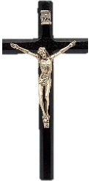

Many people are watching or listening to broadcasts of religious services on the television or radio. Perhaps you have listened to the Lutheran Hour radio broadcast on WSAM (AM 1400) Sunday mornings at 8:30 am or Immanuel Lutheran Radio Broadcast on Sunday morning at 9:00 am on WSAM (AM 1400) or watched the Worship Anew television program broadcast from Fort Wayne, Indiana, on WAQP 49 (Spectrum Channel 2) Sunday mornings at 11:30 am. All three of these ministries are seeking financial support. If interested, donations may be sent to:
Saginaw Valley Lutheran Hour, PO Box 133, Frankenmuth MI 48734
Immanuel Lutheran Radio Ministry, 300 N Sheridan St, Bay City, MI 48708
Worship Anew, Lutheran Ministries Media, 5 Martin Luther Dr, Ft Wayne IN 46825

FALL CRAFT SHOW:
This event is hosted by our own Cub Scout Pack and is being planned for Saturday, November 21st, from 10:00 am - 4:00 pm. Mark your calendar so you don’t miss out!

BOARD OF CHRISTIAN EDUCATION:
Board of Christian Education Members include: Lynda Allen, Kathy Kemp, Barbara Massey, Bonnie McIntosh, Melissa Sofian, Donna Stagray, Sharon Weiler, and Adeline Wicker.
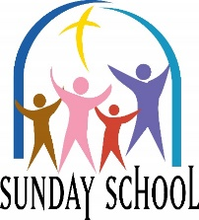
*** Sunday School will resume in September on Sunday mornings from 9:00-10:00am with sessions on September 13 and 27. Be sure to mark your calendar!
*** Sunday School children will continue learning through the Enduring Faith Bible Curriculum (Concordia Publishing) Unit 8 – Jesus Saves the World and then Unit 7 – Jesus Comes to Us.
Our Sunday Morning Sessions include: Bible Stories and related Projects, Bible Verses, Prayers, Songs, The Ten Commandments, The Lord’s Prayer, The Apostles Creed, Community Service Projects, and our Christmas Message Program in December – His Name is Jesus – The Star Leading the Wise Men.
*** The Board encourages you to extend the invitation: Baptism and Confirmation in Christ. As members of the body of Christ, we are called to live out our faith in ways that lovingly point others to Jesus. One of the greatest gifts God gives us is the means of grace – Holy Baptism and the teaching of His Word – through which faith is created, nurtured, and sustained.
We encourage you to prayerfully consider reaching out to your family, extended family, neighbors, and friends, especially those who may not be baptized or who have never been confirmed in the faith.
If you or someone you know is interested in baptism or confirmation instruction, please contact any member of the Board of Christian Education, the church office, or Pastor Erv directly.
Let us continue to walk together in faith and bring others along in the joy of life in Christ.
*** Library News: Book Donations of varied genres are being accepted for our Library program – both fiction and non-fiction titles of wholesome reading materials, along with family-oriented DVDs. Please place donations in the plastic container in the corner of the library room.
Children’s books are located on the lower two shelves, with books for mature young people located on the shelf above. Enjoy your summer reading journey!
God’s Word for Everyone vs 2
The Bible tells about God’s rescue plan;
To save us from sin’s fall,
Jesus died to save us all. Alleluia!


SATURDAY WORSHIP:

Join us on these Saturdays at 5:00pm for Holy Communion in the blue room Chapel: August 29 and September 26. Be sure to mark your calendar for these extra worship opportunities as they usually are a totally different service than Sunday’s.
NEW CHURCH OFFICE HOURS:
Beginning the first week of August, Deadra will now be in the church office on Tuesdays and Thursdays from 8:30am to 1:30pm.
EMBRACE GRACE ST. PAUL:
Back in 2024, our friends over at St. Paul, Frankenlust, started its Embrace Grace group. Embrace Grace was founded in Fort Worth, Texas, in 2008. They seek to welcome those impacted by unexpected pregnancies so that the church is becoming a place where they run ‘to’ instead of away from because of shame and guilt.
Twice a year, St. Paul hosts a 12-week program so these unexpected parents can learn about God’s love, forgiveness, and salvation through faith and repentance.
Upon completion of the classes, St. Paul’s congregation provides a baby shower for the little one. Their next shower will be Saturday, August 29 from 11am-1pm. They are seeking Amazon Gift Cards (needed by August 19) to purchase registry items. If you would like to attend the shower, please RSVP to Lily Appold at 989.385.4009. See the flyer on the bulletin board for further details.
FOOD SERVICE ASSISTANT:
Valley Lutheran High School is searching for a Food Service Assistant for the 2026-27 school year. The position is 20-25 hours per week (typically 9am-2pm). The position begins August 24th and includes benefits! Contact Karl Seidel at kseidel@vlhs.com and see the flyer on the bulletin board for further details.
CHURCH EXTENSION FUND:
In celebration of its 125th Anniversary, Church Extension Fund is launching the Ministry Partner Bonus Grant! How to participate:
- Open a new CEF note of $1,000 or more with a term of at least 24 months
- Pilgrim will automatically receive $125 Bonus Grant
- Limit one grant per household
- Visit churchextensionfund.com to get started
PILGRIM FELLOWSHIP EVENTS:
The Fellowship Team is making preparations for these fun events and activities:
September 26 – Campfire Picnic after the Saturday night worship service
October 25 – Harvest Dinner and Bingo

December 6 – Soups On and Christmas Mystery Bingo
February 7 – Pizza and Bingo
February/March – Lenten Dessert Fellowship
April 11 – New Member Potluck
Keep watching for more details as the events get closer!

PILGRIMS SERVING IN AUGUST
Sunday Elder – Paul Pett
August 2 Count Team 3
August 9 Count Team 4
August 16 Count Team 1
August 23 Count Team 2
August 30 Count Team 3
September 6 Count Team 4





2026

Sun | Mon | Tue | Wed | Thu | Fri | Sat
1

Katherine Weiler

2  Bonnie McIntosh  Sandy Wright | 3 | 4 | 5 | 6  Kevin Kot | 7 | 8
9 | 10 | 11 | 12 | 13 | 14 | 15  Aaron Sofian  Graham Miller  Steven Smith
16 | 17  Brandon Manke | 18 | 19 | 20 | 21  Adeline Wicker | 22
23  Staci Fleming | 24 | 25 | 26 | 27  Raymond Fick  Carol Pudvan | 28  Glenn Grage | 29
30 | 31






2026

Sun | Mon | Tue | Wed | Thu | Fri | Sat
1
Hall Rental - Weiler
(Parking Lot used for a Neighborhood Wedding)
2 Trinity 9  10³⁰ Holy Communion  11³⁰ Fellowship | 3 | 4 | 5 | 6  9³⁰ Chair Exercise | 7 | 8  Hall Rental - Hutter
9 Trinity 10  10³⁰ Holy Communion  11³⁰ Fellowship | 10 | 11  No Keenagers – will resume in September | 12 | 13  Newsletter  Deadline  9³⁰ Chair Exercise | 14 | 15  12⁰⁰ Beyer Baptisms
16 Trinity 11  10³⁰ Holy Communion  11³⁰ Fellowship | 17 | 18 | 19 | 20  9³⁰ Chair Exercise  10⁰⁰-12⁰⁰ Home Visitation | 21 | 22  Hall Rental - Sofian  Eagle Scout Court of Honor
23 Trinity 12  10³⁰ Holy Communion  11³⁰ Fellowship | 24 | 25  6³⁰ Cub Scout – Kickball Game Ice Cream Social | 26 | 27  9³⁰ Chair Exercise | 28 | 29  5⁰⁰ Holy Communion
30 Trinity 13  10³⁰ Holy Communion  11³⁰ Fellowship | 31



1705 Nebobish Avenue
Essexville, Michigan 48732

Penzien-Steele Funeral Home has underwritten the cost of production and mailing this month’s Pilgrim’s Progress

