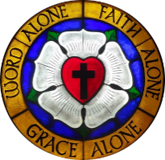

Pilgrim Lutheran Church building 1942-1958



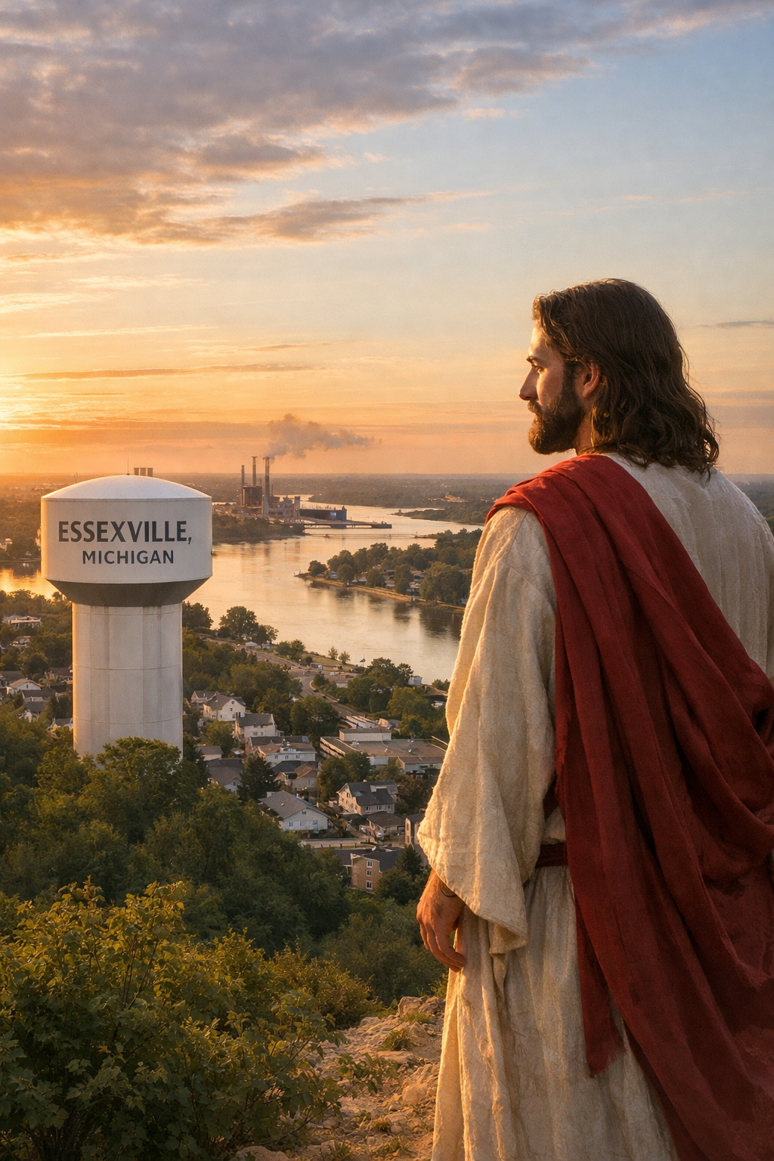

Pilgrim Lutheran Church • 1705 Nebobish Avenue • Essexville, Michigan 48732
email: pilgrimessexville@gmail.com



Greetings in the Name of the LORD!

Membership has its privileges! Or so says the advertisement from a popular credit card. Even in church we hear a bit about “membership”. We hear about baptized membership, communicant membership, voting membership, lapsed membership, etc. So, let’s talk about what being a member of the body of Christ: His Church means, as well as what types of members we are.

First of all, as most of us know, we become members of the body of Christ (the Church) the moment that we are baptized. That membership is an eternal membership. We don’t need a membership card, or offering envelopes or anything else, we are marked, called out of the darkness of this world into the world of Christ Jesus, an eternal and everlasting world of His grace.

Sometimes people talk about having to “seal” that “initial” membership with a vow, like the one we take during our Confirmation ceremony. But this is a misunderstanding of our Christian membership. We are FULL MEMBERS of the body of Christ in our baptism. We are entitled to all the privileges and responsibilities of that membership, which include on the privilege side: forgiveness of sins, co-membership with all believers in His eternal kingdom that is eternal life. On the responsibility side: we are to confess our sins, seek to live Christ-like lives and observe His Commandments with joyful hearts, not because observation of the Law will gain us heaven, but in joyful response to the heaven already won for us and delivered to each of us by Christ our LORD.

Ok, that being said, there are other types of membership within the earthly realm we call the Church. Here, membership does have its privileges, but it also has its responsibilities as well.

When we are either maturing youths or newly converted adults, we take time to study and understand just what it is that God tells us about Himself. We focus on the gifts He gives to us, and when we have the ability to then discern what right and wrong is and are able to look into our own hearts and see that we need forgiveness of sins, then we are invited to partake of His Sacrament...His very body and blood, given and shed for each of us for the forgiveness of sins, life and immortality.

We call this “communicant membership” because we are then able to receive Holy Communion, but this is not a fuller membership in the eternal realm of things.

Within our congregation, we also have rights and privileges and responsibilities. When we’ve reached the age of societal majority (currently 18 years old) we have the ability to act together with other mature members of our parish to do God’s work in this place, and to make decisions based upon His Word and the mission He has given to each of us.

This membership, whether or not you are formally a “voting member” includes the responsibility to use each of your God-given talents (time-treasure-talents) to do His work. That means participating, not just in weekly worship, but in the life of the congregation, to whatever extent you can (as opposed to whatever extent you “want to”). It means giving freely of your treasure, whether it is 10% of your income or some other percentage that you feel privileged to give, you should do it. It means using your talents, whatever they might be (singing, landscaping, painting, woodworking, cooking, etc., etc., etc.)

Remember each of your Christian memberships and serve each of them with all of your abilities as you serve the One who created, saved, and sustains you.
Festivals This Month:
There are three major feasts or festivals of the Church Year that occur this month. The first is Ascension Day, on May 14. On this festival day we celebrate Christ’s returning to heaven 40 days after His resurrection. Our circuit congregations have decided to band together to celebrate this festival. Last year we hosted the circuit, this year we are at Zion-Bay City.

The second festival is the Feast of Whitsunday, also called Pentecost, on May 24. On this day, we celebrate the birthday of the Christian Church. On the first Pentecost, fifty days after Easter, the disciples were back in Jerusalem hiding, when the Holy Spirit came upon them “like tongues of fire”. They went out into the city and proclaimed the name of Jesus Christ in various languages, even though they were not learned men. We are told that about 3,000 men were converted just that one day.

The third and final festival is the Feast of the Holy Trinity, on May 31. On this day, we celebrate the mystery of the Holy Trinity. We cannot specifically understand how God is Three in One, but that is how He has revealed Himself to us. This is that day that we also confess this mystery using the Athanasian Creed.

Our Church Year is a wonderful gift as we live the Christian life through revisiting the life of Christ and the Christian walk on a yearly basis. Join us each Sunday and holy day as we worship our LORD!

In HIS Service



Rev. Erv Hutter


May
Pilgrims in Service:
Elder: Jeff D’Archangel
Trustee: Kevin Kot
Altar Guild: Alice Kryszak
May 14th
ATTENDANCE & CONTRIBUTIONS (Needed Weekly 2026: $2,939.60)
03/25 Lent On-line: 152 In-Person Worship: 23 $ 373.00
03/29 Palm Sunday On-line: 141 In-Person Worship: 69 $ 2,010.96
04/02 Maundy Thurs. On-line: 165 In-Person Worship: 30 $ 297.00
04/03 Good Friday On-line: 150 In-Person Worship: 40 $ 285.00
Counters’ Schedule for May:
May 3 Team 2
May 10 Team 3
May 17 Team 4
May 24 Team 1
May 31 Team 2

04/05 Easter Sunday On-line: 128 In-Person Worship: 104 $ 2,895.00
04/12 Sunday On-line: 107 In-Person Worship: 48 $ 1,497.00
04/19 Sunday On-line: 87 In-Person Worship: 53 $ 3,371.00
04/25 Saturday On-line: 55 In-Person Worship: 13 $ 835.00
04/26 Sunday On-line: 61 In-Person Worship: 49 $ 2,607.00

General Fund Year-To-Date Budget vs. Income $2,196.55
Special Funds:
$25 Community Care, $15 Organ, $15 Orphan Grain Train, $240 Rainy-Day,
$237.52 Roof Replacement, $487.48 Waterline Repair, and $15 Video Ministry
PASTORAL ACTS: none

MOTHER'S DAY LOVE OFFERING:

Included in this month's Pilgrim's Progress newsletter is a special "Love Offering" envelope. As is Pilgrim's tradition, we include this envelope in the newsletters for both Mother's Day and Father's Day. Use the envelope this month to give a special gift in Celebration, Honor, or Memory of a special mother.

Email/Text Ministry:
Each week, we email the Order of Worship and the latest issue of our News & Notes. If you’re not receiving this communication, please, email pilgrimessexville@gmail.com with your name, email address, and cell phone number so we can build this database and cross-reference it with the information we already have on Shepherd’s Staff. By doing this, we have come across a few errors in our system. Thanks!

__________________________________________________________________________________________________________________________________________________________________________________________________________________________________________________
ELECTRONIC GIVING:
Pilgrim has a program which allows members to make electronic donations to the church. If you would like to participate in this voluntary program, just grab an “AUTHORIZATION FORM” from the table in the narthex, fill it out completely and return it to the church office (or to the elder on duty). You can choose the amount and frequency of your offering, just like using the traditional offering envelope. This way, even if you are not able to make it to church some weekend, you still can keep current in your ability to fund God’s work among us. If you’d like to increase your amount of giving, we can assist you with that in the office. We DO have extra boxes of envelopes available if you’d like some for our special services throughout the year.


RAINY DAY FUND: This fund has been very effective in rebuilding our savings account so that during times when weekly donations do not match our expenses, there are enough reserves to pay the bills. If you’d like to donate, Rainy Day Fund envelopes are available in the narthex.

WATERLINE REPAIR:
Our most recent waterline repair bill came in for $3,592.48. As of printing, the donation total to cover this extra expense is $3,592.48. The bill is paid in full! Thank you all so much for contributing above and beyond in order to take care of this repair to our infrastructure.


ORPHAN GRAIN TRAIN:
(OGT) is a philanthropic organization within the Lutheran Church-Missouri Synod to provide basic necessities to those who lack them. For monetary donations, envelopes are available in the narthex. The following items are on the OGT Wish List and will be transported to our local OGT Chapter Headquarters in Sebewaing where they will be prepared for shipment around the world. If you'd like to help, place your donations in the big white barrel in the hall near the mailboxes.

Diapers
Layettes
Stuffed animals
Sheets
Disposable gloves
Toothbrushes
Women's sanitary products
Adult diapers
Towels/washcloths
Bar soap
Combs
Student backpacks
New coloring books
New crayons
New pens/pencils
Writing paper/notebooks
Soccer balls
Basketballs
Bats/baseballs/gloves
New underwear (any size/age/gender)
Socks
Clean, wearable shoes
New/Like-new clothes (any size/age/gender)

PLEASE PRAY FOR OUR SHUT-INS:

A note or a visit would be welcome too!
- Jerry Brigham 1401 Smith Street Essexville, MI 48732
- Inge Cohrs 3303 Pine Village Circle #284 Valparaiso, IN 4638
- Gerald Eichinger 503 N Jackson Bay City, MI 48708
- Sandy Hines 568 N Pine Rd. #217 Bay City, MI 48708
- Duane Sprague 2004 N Brentwood Pl Essexville, MI 48732
- Carol Valley 1060 N Scheurmann Essexville, MI 48732
- Sandy Weatherbee 305 Eda Court Essexville, MI 48732
- Ruth Witzke 2534 Claude Dr Bay City, MI 48708

ATTENTION YOUTH:
We are planning a trip to Flint Bishop Airport on Tuesday, June 16. We will be greeting Veterans as they board the Honor Flight to Washington D.C. You can go to Mid-Michigan website to check it out.
Arrival at the airport will be 7:30am and we will be there for about two hours. Parents are welcome to join us! We plan to carpool from the church. For more information, please contact:
Cindy Klein @ 248.514.3395 or
Barb Massey @ 989.778.7148
ASCENSION SERVICE:
Join us at Zion Lutheran Church (510 W Ivy, Bay City) for our annual Bay City Circuit Ascension Worship Service. This time of celebrating our risen Lord’s ascension into heaven will be on Thursday, May 14 at 7:00pm. Pastor Phillip Baerwolf (Zion, BC) will be preaching, and Pastor Seth Kaiser (Trinity Monitor) will be the liturgist.
ROOF REPLACEMENT FUND:
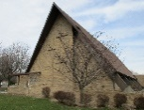
In order to keep a roof over our heads, we established this fund last summer. We have contracted with Brown Roofing, a local company, to replace the roof this year. It will likely happen during the summer and fall. Due to the war and economy, the price is now $130,000. In less than a year, our Donation Total is already $22,153.33! We will not accept the loan from the Church Extension Fund until we need to pay the contractor, which is after completion. In the meantime, we will continue to raise funds for this very important project. Thank you for being forward-thinking!


OLD TESTAMENT BIBLE STUDY CONTINUES: Join us on Tuesday evenings in the Education Center at 7⁰⁰pm as we continue to study the Old Testament’s Minor Prophets.

Sunday Morning Bible Study:
We continue our study of Christian hymnody as we look at the original text, Biblical references, origins, and more. Come and join us on Sunday mornings from 9:00-10:00am.


Sunday School Final Sessions: May 3 and May 17

Enduring Faith Bible Curriculum – Unit 9: Work of the Disciples and the Early Christian Church after Christ’s Ascension
The Plot to Kill Paul Acts 23:12-24
Paul’s Shipwreck Acts 27:9-44
Paul Writes to Timothy 2 Timothy 1; 3:14-17
Jesus Will Return John 21:1-19

Sunday School Bibles will be given to these children as the sessions end for the summer:
- Parker
- Connor
- Charlotte

Thank You to all who participated in April’s Sunday School Thrivent Action Team service project: Shoe Drive with Foster Families Navigation & Resource Center – Bay City. Watch the June newsletter for the outcome of this local community service project!

Library is up and running! Please begin using, sharing, and enjoying the reading materials. Continue to watch for new additions.

Fall 2026
After our final sessions, May 3rd and 17th, Sunday School will pause for the summer and then resume again in September. Watch the summer issues of Pilgrim’s Progress as well as the weekly News & Notes for dates!


ONLINE MINISTRY:
This continues to be a vital part of our ministry at Pilgrim, and we may never know all the souls we reach. During our last waterline repair project and due to our technical upgrades, we were even able to stream our Lenten and Holy Week Services that were held in the Blue Room Chapel. Many thanks to our generous donors who support the Video Ministry with their gifts! Special envelopes are still available in the narthex so we can continue to fund this ministry as equipment needs arise.

ESSEXVILLE RUMMAGE SALE WEEKEND:
Pilgrim’s Women’s Guild will be hosting a small concession area offering hot dogs, drinks, and chips, as well as selling baked goods during the Essexville Rummage Sales on Friday/Saturday, May 15 & 16 from 8:00am-4:00pm. They will be renting spaces again this year to people who would like to sell their items in our parking lot. To reserve a space, please contact June Feeney at 989.225.4060. Many volunteers are needed to assist with this effort, and any physical help and/or donations would be greatly appreciated. The proceeds will be shared with the Guild’s projects and Pilgrim. Watch the weekly News & Notes for further information and sign-up sheets.
__________________________________________________________________________________________________________________________________________________________________________________________________________________________________________________
LAWN CREW:
Thank you so much to all those who have signed up to help with taking care of the grass cutting this season. We appreciate you!


TO ALL OF OUR VOLUNTEERS who help out in any way at Pilgrim:


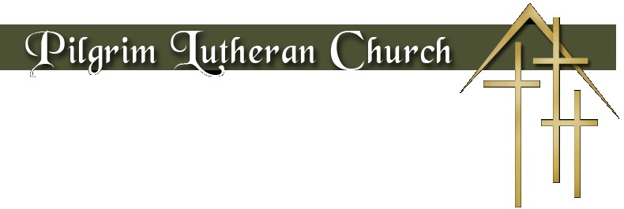

may 2026

Sun | Mon | Tue | Wed | Thu | Fri | Sat
 |  |  |  |  | 1 | 2
3 | 4  Esther Menzel | 5 | 6  Brielle Ferrer | 7 | 8 | 9  June Feeney  Don Niedrich  Kathy Pokorski
10 | 11 | 12  Mary LaFond  Neal Roller | 13 | 14  Bette Berkman | 15 | 16
17 | 18 | 19 | 20 | 21 | 22  Gary Leinberger | 23  Donna Reuther  Gary Schulz
24 | 25  Diane Pilkowski | 26  Bill Burger | 27  Bill Burger | 28 | 29  Jack Close | 30
31

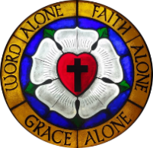

May 2026

Sun | Mon | Tue | Wed | Thu | Fri | Sat
 |  |  |  |  | 1 | 2
3 Easter 5  9⁰⁰ Bible Class  9⁰⁰ Sunday School  10³⁰ Holy Communion  11³⁰ Fellowship | 4 | 5  6³⁰ Cub Scouts  7⁰⁰ Bible Study | 6 | 7  9³⁰ Chair Exercise | 8 | 9
10 Easter 6  Mother’s Day  9⁰⁰ Bible Class  10³⁰ Holy Communion  11³⁰ Fellowship | 11 | 12  11⁰⁰ Keenagers  6³⁰ Cub Scouts  7⁰⁰ Bible Study | 13 | 14 Ascension Day  Newsletter Deadline  9³⁰ Chair Exercise  Set up for Bake Sale Concessions  7⁰⁰ Ascension Worship (at Zion) | 15 | 16  Essexville Rummage Sales  Women’s Guild Bake Sale and Concessions  8:00am – 4:00pm
17Easter 7  9⁰⁰ Bible Class  9⁰⁰ Sunday School  10³⁰ Holy Communion  11³⁰ Fellowship | 18 | 19  6³⁰ Cub Scouts  Pastors’ Conference Frankenmuth | 20 | 21  9³⁰ Chair Exercise  10⁰⁰-12noon Home Visits | 22 | 23
24 Pentecost  9⁰⁰ Bible Class  10³⁰ Holy Communion  11³⁰ Fellowship |   25 | 26  7⁰⁰ Bible Study | 27 | 28  9³⁰ Chair Exercise | 29 | 30  5⁰⁰ Holy Communion
31 Holy Trinity
9⁰⁰ Bible Class
10³⁰ Holy Communion
11³⁰ Fellowship

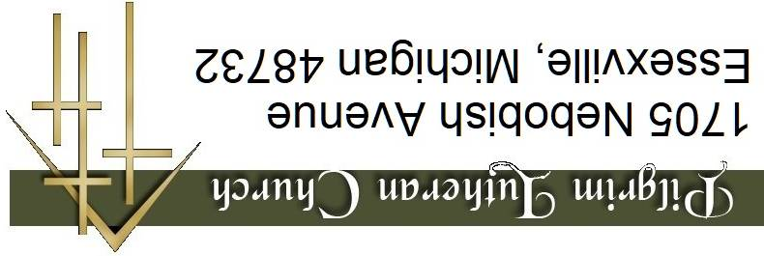
1705 Nebobish Avenue
Essexville, Michigan 48732

