
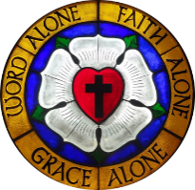
Pilgrim Lutheran Church building 1942-1958




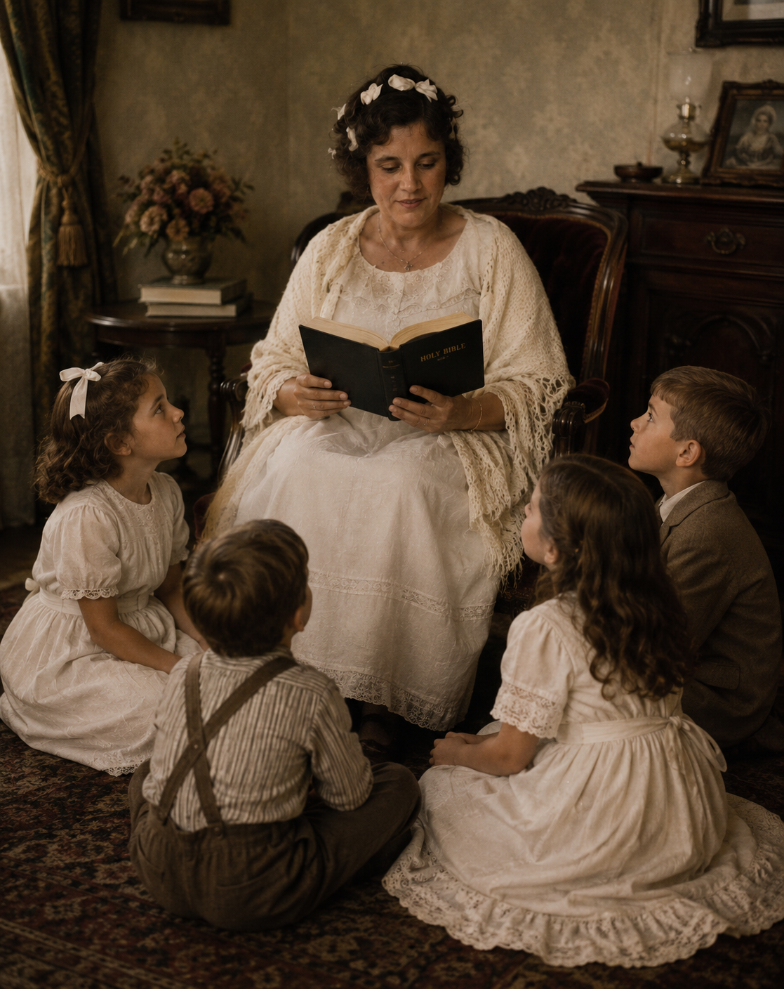

Pilgrim Lutheran Church • 1705 Nebobish Avenue • Essexville, Michigan 48732
email: pilgrimessexville@gmail.com


Question: "Why should we read the Bible / study the Bible?"

Answer: We should read and study the Bible because it is God's Word to us. The Bible is literally "God-breathed" (2 Timothy 3:16). In other words, it is God's very words to us. There are so many questions that philosophers have asked that God answers for us in Scripture. What is the purpose to life? Where did I come from? Is there life after death? How do I get to heaven? Why is the world full of evil? Why do I struggle to do good? In addition to these "big" questions, the Bible gives much practical advice in areas such as: What do I look for in a mate? How can I have a successful marriage? How can I be a good friend? How can I be a good parent? What is success and how do I achieve it? How can I change? What really matters in life? How can I live so that I do not look back with regret? How can I handle the unfair circumstances and bad events of life victoriously?

We should read and study the Bible because it is totally reliable and without error. The Bible is unique among so-called "holy" books in that it does not merely give moral teaching and say, "Trust me." Rather, we have the ability to test it by checking the hundreds of detailed prophecies that it makes, by checking the historical accounts it records, and by checking the scientific facts it relates. Those who say the Bible has errors have their ears closed to the truth. Jesus once asked which is easier to say, "Your sins are forgiven you," or "Rise, take up your bed and walk." Then He proved He had the ability to forgive sins (something we cannot see with our eyes) by healing the paralytic (something those around Him could test with their eyes). Similarly, we are given assurance that God's Word is true when it discusses spiritual areas that we cannot test with our senses by showing itself true in those areas that we can test, such as historical accuracy, scientific accuracy, and prophetic accuracy.

We should read and study the Bible because God does not change and because mankind's nature does not change; it is as relevant for us as it was when it was written. While technology changes, mankind's nature and desires do not change. We find, as we read the pages of biblical history, that whether we are talking about one-on-one relationships or societies, "there is nothing new under the sun" (Ecclesiastes 1:9). And while mankind as a whole continues to seek love and satisfaction in all of the wrong places, God—our good and gracious Creator—tells us what will bring us lasting joy. His revealed Word, the Bible, is so important that Jesus said of it, "Man does not live on bread alone, but by every word that comes from the mouth of God" (Matthew 4:4). In other words, if we want to live life to the fullest, as God intended, we must listen to and heed God's written Word.

We should read and study the Bible because there is so much false teaching. The Bible gives us the measuring stick by which we can distinguish truth from error. It tells us what God is like. To have a wrong impression of God is to worship an idol or false god. We are worshiping something that He is not. The Bible tells us how one truly gets to heaven, and it is not by being good or by being baptized or by anything else we do (John 14:6; Ephesians 2:1-10; Isaiah 53:6; Romans 3:10-18, 5:8, 6:23, 10:9-13). Along this line, God's Word shows us just how much God loves us (Romans 5:6-8; John 3:16). And it is in learning this that we are drawn to love Him in return (1 John 4:19).

The Bible equips us to serve God (2 Timothy 3:17; Ephesians 6:17; Hebrews 4:12). It helps us know how to be saved from our sin and its ultimate consequence (2 Timothy 3:15). Meditating on God’s Word and obeying its teachings will bring success in life (Joshua 1:8; James 1:25). God’s Word helps us see sin in our lives and helps us get rid of it (Psalm 119:9, 11). It gives us guidance in life, making us wiser than our teachers (Psalm 32:8, 119:99; Proverbs 1:6).

The Bible keeps us from wasting years of our lives on that which does not matter and will not last (Matthew 7:24-27).

Reading and studying the Bible helps us see beyond the attractive "bait" to the painful "hook" in sinful temptations, so that we can learn from others' mistakes rather than making them ourselves. Experience is a great teacher, but when it comes to learning from sin, it is a terribly hard teacher. It is so much better to learn from others' mistakes. There are so many Bible characters to learn from, some of whom can serve as both positive and negative role models at different times in their lives. For example, David, in his defeat of Goliath, teaches us that God is greater than anything He asks us to face (1 Samuel 17), while his giving in to the temptation to commit adultery with Bathsheba reveals just how long-lasting and terrible the consequences of a moment's sinful pleasure can be (2 Samuel 11).

The Bible is a book that is not merely for reading. It is a book for studying so that it can be applied. Otherwise, it is like swallowing food without chewing and then spitting it back out again—no nutritional value is gained by it. The Bible is God's Word. As such, it is as binding as the laws of nature. We can ignore it, but we do so to our own detriment, just as we would if we ignored the law of gravity. It cannot be emphasized strongly enough just how important the Bible is to our lives. Studying the Bible can be compared to mining for gold. If we make little effort and merely "sift through the pebbles in a stream," we will only find a little gold dust. But the more we make an effort to really dig into it, the more reward we will gain for our effort. So, please read, study and inwardly digest the Bible---God’s Word for you.

In HIS Service

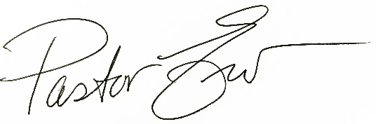

Rev. Erv Hutter


June
Pilgrims in Service:
Elder: John Manke
Trustee: Kevin Kot
Altar Guild: Alice Kryszak
June 11th
ATTENDANCE & CONTRIBUTIONS (Needed Weekly 2026: $2,939.60)
05/03 Sunday On-line: 129 In-Person Worship: 60 $ 3,062.86
05/10 Sunday On-line: 108 In-Person Worship: 61 $ 2,463.00
05/17 Sunday On-line: 81 In-Person Worship: 54 $ 3,477.00
05/24 Sunday On-line: 55 In-Person Worship: 46 $ 3,182.00

General Fund Year-To-Date Budget vs. Income $ 2,623.01
Special Funds Love Offering $440, Organ $25, Orphan Grain Train $20,
Rainy-Day Fund $70, and Roof Replacement $715
PASTORAL ACTS: New Member – Christopher Arnold


FATHER'S DAY LOVE OFFERING
Included in this month's Pilgrim's Progress newsletter is a special "Love Offering" envelope. As is Pilgrim's tradition, we include this envelope in the June newsletter for Father's Day. Use the envelope this month to give a special gift in memory of or in honor of a special father.

Email/Text Ministry
Each week, we email the Order of Worship and the latest issue of our News & Notes. If you’re not receiving this communication, please, email pilgrimessexville@gmail.com with your name, email address, and cell phone number so we can build this database and cross-reference it with the information we already have on Shepherd’s Staff. By doing this, we have come across a few errors in our system. Thanks!

__________________________________________________________________________________________________________________________________________________________________________________________________________________________________________________
ELECTRONIC GIVING
Pilgrim has a program which allows members to make electronic donations to the church. If you would like to participate in this voluntary program, just grab an “AUTHORIZATION FORM” from the table in the narthex, fill it out completely and return it to the church office (or to the elder on duty). You can choose the amount and frequency of your offering, just like using the traditional offering envelope. This way, even if you are not able to make it to church some weekend, you still can keep current in your ability to fund God’s work among us. If you’d like to increase your giving amount, we can assist you with that in the office. We DO have extra boxes of envelopes available if you’d like some for our special services throughout the year.


ORPHAN GRAIN TRAIN (OGT)
This philanthropic organization within the Lutheran Church-Missouri Synod provides basic necessities to those who lack them. For monetary donations, envelopes are available in the narthex. The following items are on the OGT Wish List and will be transported to our local OGT Chapter Headquarters in Sebewaing where they will be prepared for shipment around the world. If you'd like to help, place your donations in the big white barrel in the hall near the mailboxes.

Diapers
Layettes
Stuffed animals
Sheets
Disposable gloves
Toothbrushes
Women's sanitary products
Adult diapers
Towels/washcloths
Bar soap
Combs
Student backpacks
New coloring books
New crayons
New pens/pencils
Writing paper/notebooks
Soccer balls
Basketballs
Bats/baseballs/gloves
New underwear
(any size/any age)
Socks
Clean, wearable shoes
New/Like-new clothes (any size/age/gender)

RAINY DAY FUND

This fund has been very effective in rebuilding our savings account so that during times when weekly donations do not match our expenses, there are enough reserves to pay the bills. If you’d like to donate, Rainy Day Fund envelopes are available in the narthex.

ROOF REPLACEMENT FUND
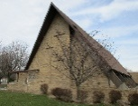
In order to keep a roof over our heads, we established this fund last summer. We have contracted with Brown Roofing, a local company, to replace the roof this year. It will likely happen during the summer and fall. Due to the war and economy, the price is now $130,000. In less than a year, our Donation Total is already $22,868.33! We have applied, but will not accept the loan from the Church Extension Fund until we need to pay the contractor, which is after completion. In the meantime, we will continue to raise funds for this very important project. Thank you for being forward-thinking!

COUNT TEAMS FOR JUNE
June 7 Team 3
June 14 Team 4
June 21 Team 1
June 28 Team 2
July 5 Team 3


Sunday Morning Bible Study
Join us as we continue studying our Christian hymnody on Sunday mornings during June from 9:00-10:00am.
TUESDAY EVENING BIBLE STUDY
We have finished up the Minor Prophets of the Old Testament and will take a break for the summer months. Watch the News & Notes for our first gathering in September as we begin a new study on the book of Psalms!

ONLINE MINISTRY
This continues to be a vital part of our ministry at Pilgrim and we may never know all the souls we reach. We’ve made some necessary technical upgrades, thanks to generous donors who supported the Video Ministry with their gifts! Special envelopes are still available in the narthex so we can continue to fund this ministry as equipment needs arise.

DEVOTIONAL BOOKLETS
The NEW SUMMER ISSUE of Our Daily Bread is now available in the narthex. These devotional books cover the months of June, July, and August and are provided to us free of charge by Our Daily Bread Ministries in Grand Rapids. We have several extras, so please share a copy with a friend or neighbor.
SATURDAY WORSHIP
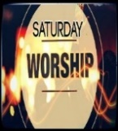
Our next Saturday evening service will be held Saturday, June 27 at 5⁰⁰pm. Join us in the Blue Room Chapel for this time of worship with Holy Communion. Then mark your calendar for the rest of the summer services: July 25 and August 29.

THANK YOU
Pilgrim’s Women’s Guild wishes to express their humble gratitude for the many donations of:
baked goods, concession items, and the hours of manpower for the Essexville Rummage Sale Weekend! Preliminary results show that it was definitely worth our time and energy with a profit of $1,367! Bless you all!

ATTENTION YOUTH
We are planning a trip to Flint Bishop Airport on Tuesday, June 16. We will be greeting Veterans as they board the Honor Flight to Washington D.C.
Arrival at the airport will be 7:30am and we will be there for about two hours. Parents are welcome to join us! We plan to carpool from the church at 6:00am and leave by 6:15am. Funds are available for gas reimbursement and short-term parking is free. For more information, please contact:
Cindy Klein @ 248.514.3395 or
Barb Massey @ 989.778.7148
GOLF OUTING
Immanuel Lutheran’s 2nd Annual Fellowship Classic Golf Outing will be coming on Saturday, July 18 at Green Hills Golf Course in Pinconning. Check out the flyer on the bulletin board for further details and how you can participate!

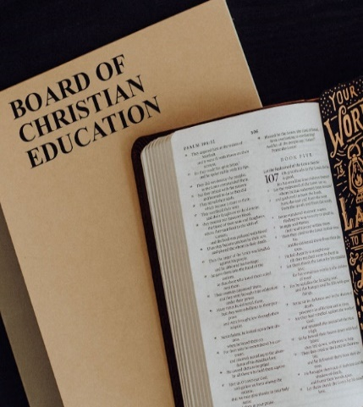
BOARD OF CHRISTIAN EDUCATION
Members include: Lynda Allen, Kathy Kemp, Barbara Massey, Bonnie McIntosh, Melissa Sofian, Donna Stagray, Sharon Weiler, and Adeline Wicker

SUNDAY SCHOOL
Sunday morning sessions are on break for the summer. We will resume again in September. Please watch future issues of the Pilgrim’s Progress and the weekly News & Notes for those dates!

VACATION BIBLE SCHOOL
Instead of hosting our own VBS this year, we urge families to consider attending other VBS programs. We will share that information as it comes in from our sister congregations. Watch the News & Notes for these invitations that will be posted on the bulletin board in the hallway.
God’s Word for Everyone

4. The Bible is God’s Work for everyone;
It’s Good News we can share,
Here at home and everywhere.
Alleluia!
SUNDAY SCHOOL STATISTICS
As of May 2026:
14 Sunday School age children
5 Cradle Roll age children

4 Children are receiving Bibles as this year finishes – Caleb, Parker, Connor, and Charlotte

THRIVENT ACTION TEAM SERVICE PROJECT
Back in April, our Sunday School teamed up for the Shoe Drive with Foster Families Navigation & Resource Center in Bay City. The agency goal was to collect 250 bags (estimated 6,250 pairs of shoes). Pilgrim’s effort provided 3 bins and 1 box of shoes through this project:
- New shoes were purchased with a few hundred dollars provided through seed money from Thrivent, gifted contributions, Kohl’s cash, and discounts.
- Many pairs of new and gently used shoes were generously donated to our bins!
- Community Agency information of this project was provided to all, as well as Christian educational materials purchased for our Sunday School program.

LIBRARY
Donations of books of varied genre are being accepted for the Library program – both fiction and non-fiction titles of wholesome reading materials, along with family-oriented DVDs. Please place donations on the table in the designated Library Room for shelving.

Members have access to the Library whenever the church is open. They will be able to read in the Library or in the comfy seats outside the Library room…an inviting area for all. Also, books may be taken home to read, then returned whenever finished.

Our “Little Library” of Christian reading materials still exists by the north entrance of the church.
If there are any questions or additional comments, please reach out to Lynda Allen.

Church Office Hours:
Tuesdays 8:30-11:30am
Wednesdays & Thursdays
9:00am-12:00 noon

Deadra Hurley
Secretary
(989) 893-7224
pilgrimessexville@gmail.com



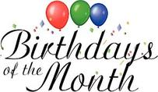
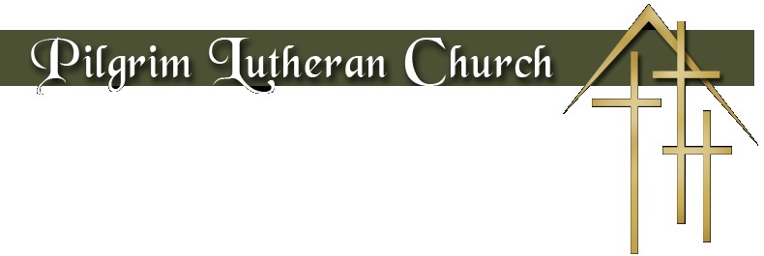
JUNE 2026

Sun | Mon | Tue | Wed | Thu | Fri | Sat
 | 1 | 2  Max D’Archangel | 3  Dee Mast | 4 | 5  Sophia Black
7 | 8 | 9 | 10  Don Jones | 11  Katie Hutter | 12  Dawn Hutter  Donna Stagray | 13
14  Jill Bush  Cynthia Julian | 15  Jake Thiel | 16 | 17 | 18 | 19 | 20  Sandy Hines
21  Brandi D’Archangel | 22 | 23 | 24 | 25 | 26  Jeffrey Spenner | 27  Barb Fick
28 | 29 | 30  Jacob Beyer  Madison Wagner

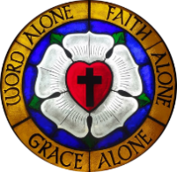

June 2026

Sun | Mon | Tue | Wed | Thu | Fri | Sat
 | 1 | 2 | 3 | 4  9³⁰ Chair Exercise | 5 | 6
7 Trinity 1  9⁰⁰ Bible Class  10³⁰ Holy Communion  11³⁰ Fellowship | 8 | 9  11⁰⁰ Keenagers | 10 | 11  9³⁰ Chair Exercise  Newsletter Deadline | 12 | 13
14 Trinity 2  9⁰⁰ Bible Class  10³⁰ Holy Communion  11³⁰ Fellowship | 15 | 16 | 17 | 18  9³⁰ Chair Exercise  10⁰⁰-12noon Home Visits | 19 | 20
21 Trinity 3  9⁰⁰ Bible Class  10³⁰ Holy Communion  11³⁰ Fellowship | 22 | 23 | 24 | 25  9³⁰ Chair Exercise | 26 | 27  5⁰⁰ Holy Communion
28 Trinity 4  9⁰⁰ Bible Class  10³⁰ Holy Communion  11³⁰ Fellowship | 29 | 30


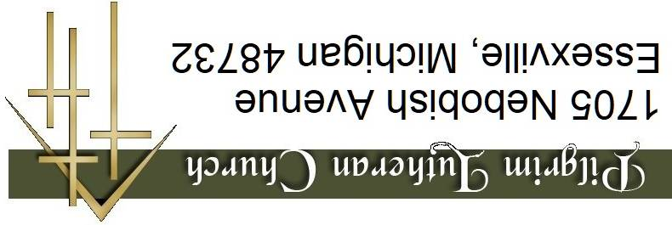
1705 Nebobish Avenue
Essexville, Michigan 48732

