

Pilgrim Lutheran Church building 1942-1958



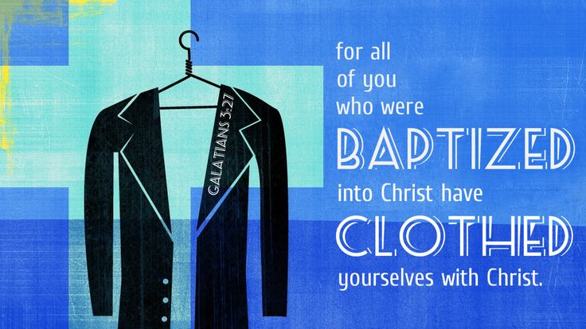





Pilgrim Lutheran Church • 1705 Nebobish Avenue • Essexville, Michigan 48732

pilgrimessexville@gmail.com • 989.893.7224


Dressing for Jesus?
For as many of you as were baptized into Christ have put on Christ. - Galatians 3:27

It DOESN’T matter what you wear to church. It DOES matter what you wear to church. Well, which is it? It doesn’t matter to Jesus what you wear to church, but it does matter to your neighbor.
Every so often the topic comes up about how we should dress for worship. In the “olden days” (like when your grandparents and maybe your parents were your age) women wore dresses to church and men wore suits. After all, they reasoned, how can you not dress your best for the LORD? It shows reverence and respect. Fast forward to today. In many churches, people come dressed pretty casually: ﬂip ﬂops, tank tops, shorts and jeans. Older members who look at the kids dressed this way often remark, “Well someone ought to say something! How can their parents let them dress that way!” The kids, of course, have mastered the art of appealing to some generic love of God: “God doesn’t care what you wear because He just wants you there!” So, what to wear to church?
It really doesn’t matter to Jesus. St. Paul writes that Jesus gave Himself up for the church, washing her and making her spotless and presenting her to Himself in splendor as a pure bride with no spots or blemishes or wrinkles. (Ephesians 5:26-27) Paul also says that to be baptized with Christ is to be clothed with Jesus. When you go to church, you are actually wearing Jesus, no matter what clothes you put on that morning. In fact, you are wearing Him every day. Every moment and every day of your life, your Father in heaven looks at you and sees not jeans or suits or dresses or ﬂip ﬂops. He sees Jesus. Perfect, holy, spotless, righteous, Jesus. When you sin, your sins are forgiven. God doesn’t see them either. What clothes you wear doesn’t bother God because you’re wearing Jesus.
At the cross, Jesus was hung naked and in shame for your sins. What happened to His clothes? They were taken by the sinful soldiers who nailed Him there.
What a picture! Jesus dies naked, a reminder of sin and shame; you get His clothes! So, no worries about how you appear before Jesus! He’s made you look great. He’s covered you with Himself. It doesn’t matter to Jesus what outﬁt you’ve got on since it’s all covered by Him!
But it does matter to your neighbor what you wear. If what you’re wearing in church or what you’re doing while you should be paying attention to God’s Word is a distraction and hindrance to others, then we need to repent and rethink what we’re doing. Young ladies: if the clothing you wear is a distraction to the young men around you, perhaps you should rethink your choice of outﬁts. Maybe the LORD’s house isn’t the best place for that low cut top if it takes someone’s mind off of God’s Word! Young men: if your dressing like a slob makes people shake their head at you instead of paying attention to Pastor, perhaps it’s time to rethink what you throw on for a Sunday Morning. Maybe the LORD’s house isn’t the best place for that death-metal t-shirt with the bloody skull on it! Again, it’s not as if the LORD is offended, but these things distract your brothers and sisters in Christ who, like you, should be in church to hear the LORD’s Word and receive His gifts.
The same goes with cell phones and texting, with whispering and chatting before and during the service, and with going in and out during the worship service. There’s nothing you can do to irritate the LORD. He has His Word and gifts for you! But it might drive your neighbor nuts. So, there is room for some repentance. Repent of doing things that take your own mind and heart away from paying attention to the gifts Jesus has for you. Repent of doing things that tempt your neighbors’ minds and hearts away from God’s Word. The LORD knows our ﬂesh has enough distractions in church without us adding to them for ourselves or others!
To those who say it matters how you dress for the LORD, you can conﬁdently answer, “No it doesn’t! To those who say that it doesn’t matter how you show up for church you can say, “Oh yes it does!” Doesn’t matter for Jesus. Matters for your neighbor.
When the LORD sees you, He sees no sins. No spots. No blemishes. No wrinkles. No stains. He sees the righteousness which he earned for you on Calvary and in which He has wrapped you up in your Baptism. When your neighbor sees you, well, they should see the same thing: a redeemed child of God who is perfect in God’s sight. But in case they don’t, let’s not give them a reason to think about something else! And all together with them, with the suits and the jeans, the ﬂip ﬂops and the dress shoes, the young and the old, the stodgy and the carefree, we can rejoice to be the holy and beautiful bride of Christ. That’s exactly what Jesus has made us and how He sees us. And His righteousness is clothing that looks amazing no matter what the fashion trends or season, whether we are in His house or out in the world. My, but don’t you look great dressed in Jesus!



PILGRIMS SERVING IN JANUARY

Elder: Aaron Sofian (989.545-9177)
Altar Guild: Alice Kryszak (989.893.3664)
Trustee: Kevin Kot (989.225.2913)
Thursday, January 15


Count Teams:
January 4 – Team 1
January 11 – Team 2
January 18 – Team 3
January 25 – Team 4
February 1 – Team 1

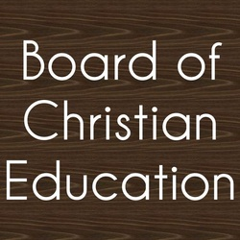

MARK YOUR CALENDAR!
Sunday School Dates

* January 11 and 25
* February 8 and 22
Service Project News

*THANK YOU for the outpouring of generosity in fulfilling the needs, wishes, and favorite snacks/treats for the 11 group home residents in our area in conjunction with a Thrivent Action Team! A donation of specially designed Christmas Story booklets were also created for the residents as well as our Sunday School children who receive their leaflets through the mail.

*THANK YOU to our youth who completed both Water Filtration and Solar Light Kits as a service project via Thrivent Cause Kits!

Enduring Faith Bible Curriculum for January
Unit 9: The Work of the Disciples and the Early Christian Church in Acts after Christ’s Ascension
The Plot to Kill Paul – Acts 23:12-24
Paul’s Shipwreck – Acts 27:9-44
Paul Writes to Timothy – 2 Timothy 1 and 3:14-17

This Little Light of Mine

This little light of mine, I’m gonna let it shine.
This little light of mine, I’m gonna let it shine.
This little light of mine, I’m gonna let it shine.
Let it shine, let it shine, let it shine.


LIBRARY … Watch for the beginning development of our church library for all to enjoy!

ATTENDANCE & CONTRIBUTIONS (Needed Weekly for 2025: $2,943)

11/26 (Thanksgiving Eve) n/a In-Person Worship: 14 $ 595.00
11/29 (Saturday) n/a In-Person Worship: 14 $ 740.00
11/30 On-line: 121 In-Person Worship: 26 $ 5,090.36
12/3 (Advent) n/a In-Person Worship: 15 $ 59.00
12/7 On-line: 73 In-Person Worship: 42 $ 2,261.00
12/10 (Advent) n/a In-Person Worship: 10 $ 400.00
12/14 On-line: 63 In-Person Worship: 61 $ 3,498.00
12/17 (Advent) n/a In-Person Worship: 19 $ 340.00
12/21 On-line: 25 In-Person Worship: 48 $ 2,843.00

Year to Date Income vs. Budget $ (-8,997.46)

SPECIAL GIFTS: Community Care $15, Love Offering $30, Mahlburg Mission $100, Organ $15,
Orphan Grain Train $15, Rainy Day Fund $85, Roof Replacement $8,465, and Video Ministry $15

WATERLINE REPAIR (bill was $7,420.93) IS PAID IN FULL $7,425.36!
Roof Replacement Fund Donation Total to Date $17,515.81



PASTORAL ACTS – None

BIBLE STUDY
Tuesday Evening Adults – Our study of the Old Testament Prophets, beginning with Isaiah, will resume on Tuesday, January 6 at 7⁰⁰pm. You are welcome to join us in the Education Room any Tuesday you are available!


KEENAGERS
For all members 55 and over! Join us for food and fellowship each month on the second Tuesday of the month in the Education Room. Bring a dish to pass. Next gathering is Tuesday, January 13 at 11⁰⁰ am.

Pilgrim’s Prayer Network

The prayer warriors will meet again Wednesday, January 7 at 11³⁰ am. If you have any prayer requests or would like to become a prayer warrior, you can contact Clarice Richards at (989) 284-4039 or mar19india06@gmail.com and the Prayer Network will add you or your concern to their prayers. These are kept confidential unless you request otherwise.
SPECIAL ENVELOPES
In addition to being able to sponsor Altar Flowers and our Order of Worship each week (sign-up sheets and envelopes are in the hallway), we also have a variety of special envelopes available in the Narthex for these extra giving opportunities:
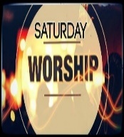

Community Care Fund – Gifts donated to this fund are sent to one of our many community organizations.

Love Offering Envelopes are still available in the narthex in case you would like to make a special donation this winter in honor, celebration, or memory of a loved one.

Memorials – Donations may be made in memory of friends and family.
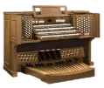
Organ Fund – We use the money in this fund to help regularly maintain and tune our pipe organ which is a major asset to our worship experience.

Orphan Grain Train – These gifts are sent to assist with helping those in need both here in the U.S. and abroad.

Rainy Day – Gifts given to this fund are of vital importance as we need to use it when our expenses of running the church don’t keep up our weekly tithes and offerings.
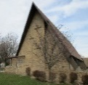
Roof Fund – We need to prepare for the future of our buildings and have established a fund to cover the replacement of our roof.
Donation Total to Date = $17,515.81

SATURDAY WORSHIP
We will continue to hold a Saturday evening worship service on the last Saturday (usually) of the month at 5⁰⁰ pm. This service will be a Holy Communion service and will be held in the Blue Room Chapel. If you would like a Saturday evening worship experience, please plan on attending: January 31 and then February 28, and March 28.
__________________ ___________________________________________________________________________________________________
2026 OFFERING ENVELOPES
Your offering envelopes are available in the hallway and you may begin using them for our first service of the new year on January 4. If you currently give online and would like a box of envelopes for our special services, we do have a few extra boxes. If you don’t see your box, please contact Deadra in the church office.
SUNDAY MORNING
Adult Bible Study – Join us on Sundays from 9⁰⁰-10⁰⁰am. We are studying the hymns of the day. What do they mean? What is their history? If they are translations from German or Latin, what were the original hymnist’s words? Come and join us any Sunday you can for these informative sessions!

CHRISTMAS DECORATION TAKEDOWN

will occur on Saturday, January 10, starting at 9⁰⁰ am. If you have any time to come and help, your assistance would be appreciated. Many hands make quick work!

CHRISTMAS CARDS
Remember to bring in your used RELIGIOUS Christmas card covers. Our LWML ladies will be using them to make books that tell the Christmas story. These booklets will be used for outreach and shut-ins. Just place them in the box in the hall as you enter the narthex.
IMMANUEL FOOD PANTRY
The volunteers gratefully picked up our donations for the Christmas Distribution to 35 families in need. Thank you so much for helping! We will continue to collect items for regular distribution over the winter months. Just place your donations in the bin in the hallway. Thank you for helping those in need!
2026 CALENDARS
Pick up your new calendar, complete with Bible passages, are available in the narthex, compliments of Penzien Steele Funeral Home. There are plenty, so feel free to share an extra one with a friend or neighbor!

PILGRIM FELLOWSHIP EVENT
Join us on Sunday, January 18 at 11³⁰ am for a time of fellowship with pizza and games! Mark your calendar and watch the News & Notes for more details.


THANK YOU!
The Women’s Guild would like to thank everyone for their support and success of The Christmas Bake Sale! We truly appreciate all the donations of baked good and the volunteers who set up, worked, and cleaned up.
THANK YOU!
On behalf of my family and myself, I’d like to thank all of you who sent cards, gave gifts, or said a prayer for us during the Christmas Season. May you and yours be filled with the love of Christ into this new year of 2026!

LUTHERAN HOUR-RALLY AND MINISTRY SUMMIT- Do we live in such a way that people are curious about what motivates us to live distinctively different lives? And if they did ask us, would we be prepared to give an account of the hope that is within us? Don’t miss our Congregational Ministry Summit on January 31 in Frankenmuth, that will help you both be better enabled to live a life that evokes questions and be better prepared to give an account of that inner hope in Christ. Our theme verse is 1 Peter 3:15 “… but in your hearts honor Christ the Lord as holy, always being prepared to make a defense to anyone who asks you for a reason for the hope that is in you; yet do it with gentleness and respect.” 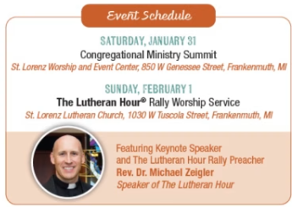








Sun | Mon | Tue | Wed | Thu | Fri | Sat
 |  |  |  | 1  Carol Jankens  Eileen Schulz | 2 | 3  Monica Anthony  John Manke
4 | 5 | 6 | 7  Sam Carlin | 8  Ken Caspers | 9 | 10
11 | 12  Lynda Allen | 13 | 14 | 15 | 16  Carol Borchardt | 17
18  Renee Reinke  Ruth Witzke | 19  Al LaFond | 20 | 21 | 22  Inge Cohrs | 23  Carol Valley  Debra  Wentworth | 24
25 | 26 | 27 | 28 | 29 | 30 | 31
A Blessed and Happy Birthday

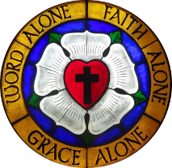


Sun | Mon | Tue | Wed | Thu | Fri | Sat
 |  |  |  | 1  New Year’s Day  Office Closed | 2 | 3
4 Epiphany (Observed)  9⁰⁰ Bible Class  10³⁰ Holy Communion  11³⁰ Fellowship | 5 | 6  11³⁰ Yoga  6³⁰ Cub Scouts  7⁰⁰ Old Testament Bible Study | 7  11³⁰ Prayer Network | 8  9³⁰ Chair Exercise | 9 | 10  9⁰⁰am Christmas Decoration  Take-Down
11 Epiphany 2  9⁰⁰ Bible Class  9⁰⁰ Sunday School  10³⁰ Holy Communion  11³⁰ Fellowship | 12  11⁰⁰ Worship at Hampton Meadows | 13  11⁰⁰ Keenagers  11³⁰ Yoga  6³⁰ Cub Scouts  7⁰⁰ Old Testament Bible Study | 14 | 15  9³⁰ Chair Exercise  10⁰⁰-12⁰⁰ noon Homebound Visitation  NEWSLETTER DEADLINE | 16 | 17
18 Epiphany 2  9⁰⁰ Bible Class  10³⁰ Holy Communion  11³⁰ Fellowship with Pizza/Games | 19  Newsletter Deadline | 20  11³⁰ Yoga  6³⁰ Cub Scouts  7⁰⁰ Old Testament Bible Study | 21 | 22  9³⁰ Chair Exercise | 23 | 24
25 Transfiguration  9⁰⁰ Bible Class  9⁰⁰ Sunday School  10³⁰ Holy Communion  11³⁰ Fellowship | 26 | 27  11³⁰ Yoga  6³⁰ Cub Scouts  7⁰⁰ Old Testament Bible Study | 28 | 29  9³⁰ Chair Exercise | 30  6³⁰ Set-Up Pinewood Derby | 31  9⁰⁰ Cub Scouts Pinewood Derby  5⁰⁰ Holy Communion


